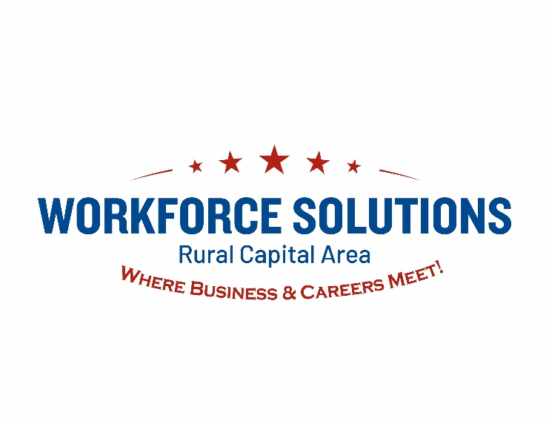

Human Resources, Payroll and Benefits Brokerage Services
ADDENDUM #1 QUESTIONS & RESPONSES
320-15-2501
MONDAY, AUGUST 25, 2025

The Rural Capital Area Workforce Development Board, Inc. d.b.a. Workforce Solutions Rural Capital Area (WSRCA) is posting RFQ 320-15-2501 Addendum #2 Questions & Responses.
Questions & Responses:

- What is the current benefits set up?
WSRCA offers the following benefits:
  - Fully Funded Medical, Dental, Vision, Employee Life
  - Voluntary Purchase Coverages – Additional Life Ins (AD&D), Disability, STD/LTD, Flexible Spending Account, Dependent Care Account, Pet Health
  - Ancillary: EAP, Travel Protection, EAP Medical Bill Saver

- Who are the carriers, funding style, and plan designs?
The carriers and plan designs are as follows:
  - Medical: BCBS/Age Banded Premiums (Employer contributes 93% to employee only premium)
  - Vision/Dental/Life/Disability: Sunlife (Employer contributes 100% to employee only premium)
  - FSA/DCA: Proficient Benefit Solutions
  - Pet: ASPCA
  - Travel/EAP: Unum Insurance

- How many employees are enrolled versus eligible for the plan?
WSRCA has 31 total employees and 31 eligible employees, with 26 enrolled in the health insurance plan and 5 who have waived enrollment. WSRCA is open to responses that may place employees into a larger benefits group for competitive health brokerage and improved benefits for employee and children and employee and family options.

- What is the current dialogue around health insurance claims?
Currently, claims information is provided as part of the annual renewal process.
- Does the WSRCA look into how they are running in a premium vs claims? If available, it would be great to see any claims information during the process.

Currently, claims information is provided as part of the annual renewal process. The claims information is not currently available.

- For COBRA, ACA, and 401k, what is the current set up?
COBRA and ACA are managed by our current payroll and HR services provider. The 401k is administered through a third party administrator in cooperation with the payroll services provider for payroll deductions.

- Are these plans and services done through a third party administrator, or by the current vendor/ broker?

  - COBRA/ACA/Health Insurance brokerage - current vendor
  - 401k- separate brokerage with a third party administrator
- Is there a platform that is currently being used to house benefits?
  - G&A Partners/WorkSight
- How will the agency weight national firms that do all things under one roof, versus a
partnership of multiple companies that can fill all of the needed services?

WSRCA is seeking a comprehensive solution for payroll processing, HR Services, performance management, LMS, health insurance brokerage and retirements benefits brokerage. Respondents may include multiple companies working together to provide the full scope of services or be one organization that provides all requested services under one roof.

- What is the current active employee count for the Board?
  - Approximately how many are hourly vs. salary?
WSRCA has a total of 31 employees, with 29 salaried employees and 2 hourly employees.
  - Approximately how many are full time vs part time?
WSRCA currently has 31 full time employees.
- Who is the Board’s current provider of payroll and HR software services? (company name and software name).

The current provider is G&A Partners, using WorkSight.
- Are you using timekeeping and would you like timekeeping included in the proposal?
  - If yes, who is the current provider? (company name and software name)
Yes, the current provider is G&A Partners, which uses WorkSight.
- Are all employees on direct deposit?
Yes
- What is the current pay frequency / frequencies?
  - Please include the beginning and end dates as well as the check date for the current pay cycle.

WSRCA operates on a bi-weekly pay cycle with the following pay periods and pay dates:
        - Pay Period: Current Pay Period: 08/17/2025-08/30/2025
        - Pay Date: 09/05/2025

- Does the Board currently use web based employee onboarding?
- Yes
- Does the Board currently use a benefits administration tool?
- All processed through G&A Partners
- Who is the agency that currently provides health benefits?
  - Which carrier does the Board currently use through this agency?
Through G&A Partners, the current health benefits providers are:
  - Medical: BCBS
  - Vision/Dental/Life/Disability: Sunlife
  - FSA/DCA: Proficient Benefit Solutions
  - Pet: ASPCA
  - Travel/EAP: Unum

- Does the Board currently have specific HR data, such as certifications and licenses, company assigned assets, etc. they would like tracked by the HR system?
  - If so, please provide a list of those items.

While this is not currently a function available / used at this time, respondents should provide as much information as possible about potential tools / additional benefits that are available in the response.

- Which general ledger reporting tool does the Board utilize?
WSRCA uses Abila / MIP for accounting.
  - At what level of detail are journal entries currently booked?
Entries are booked by fund source, GL code, cost category, function and location. WSRCA has approximately 40 funding sources at any given time.

- Does the Board have to do any grant reporting using payroll data?
  - If yes, please describe the reporting requirements.
Yes, while WSRCA uses a cost allocation model for most positions, staff may also directly charge time to grants. Fringe and other benefits must be calculated based on those charges and reported to the applicable grant authorities.

- Please provide a summary description of the current leave policy / policies and any specific needs for tracking and requesting time off.

See Attachment A. WSRCA PTO Policy

- Please confirm the Board will accept proposals from providers that can only provide a portion of the requested services. (ie – payroll, time, and HR services, but not benefits).

WSRCA is seeking responses that include all services requested. Respondents do not need to offer all services under one roof but should provide options for services not included.

- For learning management, is the Board looking for a tool to manage the content or will they also be seeking content from the provider?

WSRCA is looking for a tool that can manage local training content as well as seeking LMS content from the provider.

- Does the Board currently have a retirement plan in place?
Yes
  - If so, what type of plan is it and who is the provider?
Yes, 401k, TransAmerica
  - Will this plan stay in place or is it part of the RFQ?
The RFQ is requesting responses to all services requested. Respondents do not need to offer all services under one roof but should provide options for services not included.

- The number of employees this project will be for.
WSRCA currently has 31 FTE’s.
- The prior contract award amount.
This information is currently not available.
- Are we able to submit our proposal for all features except benefit brokerage?
This RFQ is requesting responses to all services requested. Respondents do not need to offer all services under one roof but should provide options for services not included.

- Can WSRCA provide an organizational chart?
Yes, see Attachment B WSRCA Organization Chart.
- How many employees are currently supported by HR, and what are the typical annual turnover and new hire numbers?

WSRCA currently has 31 employees, all full time, with 29 salaried employees and 2 hourly employees. Our turnover rate in 2024 was 6.4%.

- What is the anticipated growth of the organization over the next 5 years?
WSRCA is a non-profit organization, funded through federal, state and philanthropic grants. We regularly seek out new revenue streams through competitive awards and grants, but do not anticipate our growth over the next five years to be more than 10%.

- Does WSRCA currently have an internal HR team, or would Red Envelope be the primary HR function for the organization?

Yes, WSRCA currently has one Human Resources Executive on Staff to provide the primary HR functions for the organization. The selected vendor would provide processing support.

- Does WSRCA require the selected vendor to provide on-site support in the service region, or will services be fully remote/virtual?

Remote/Virtual is acceptable.
- What are the top HR challenges or priorities WSRCA hopes to address with this contract (e.g., compliance, performance management, employee engagement, training)?

The top HR priorities WSRCA is addressing with the RFQ include:
- Improved Benefits Offerings to employees and their families
- Increased participation in the retirement offering
- Streamlined Goal and Performance Management with reporting functionality

- Will preference be given to Texas-based vendors or vendors with demonstrated experience serving workforce development boards?

Please review Section 2.7 Proposer Qualifications & Competencies and 5.3 Evaluation Criteria for demonstrated experience.

- Are there existing HRIS/payroll/LMS platforms currently in use, and is WSRCA seeking to transition from those systems or supplement them?

The HRIS / payroll / LMS platform is proprietary to the current vendor and WSRCA recognizes a transition to a new system may occur.

- Since funding is tied to federal and state allocations, does WSRCA anticipate any budget limitations or caps vendors should be aware of when structuring proposals?

An administrative cap is placed on WSRCA by each state or federal grant received. Respondents should structure proposals to fully satisfy the services requested in the RFQ. Programming the caps into the payroll system may be helpful when tracking staff payroll, but no caps will be applied to vendors on the administrative costs to provide the services requested.

Attachment A – WSRCA PTO Policy

WSRCA RFQ 320-15-2502 Addendum #2 Q&A

PTO can be taken for vacation, personal days or sick days according to the employee’s choice and may be carried over into the next year. Carry-over is limited and an employee’s PTO balance may not exceed 168 hours. Upon reaching 168 hours, PTO hours will stop accruing to PTO and will not resume until the balance falls below 168 hours. Any PTO not accrued will be transferred to the employee’s extended leave bank with a cap set at 480 hours. Any amount/s above the 168/480-hour limits will be forfeited and will not be restored.

Employees are encouraged to manage their PTO effectively. Employees must request PTO time and requests are subject to management approval. Requests for multiple days (i.e. vacation) must be approved two weeks in advance.

PTO hours are paid at the employee’s current straight time rate of pay. PTO will not be paid out in lieu of actually taking the time off. PTO will not be paid in addition to holiday pay or for any other time the employee is compensated.

PTO - All regular full-time employees shall accrue PTO based on length of employment, as follows:

- 0 through 2 years of employment – one hundred forty (140) hours per year (accrued equally over 26 pay period at 5.385 hours per pay period)

- 3 through 5 years of employment - one hundred sixty-four (164) hours per year (accrued equally over 26 pay periods at 6.308 hours per pay period)

- 6 through 10 years of employment - one hundred eighty (180) hours per year (accrued equally over 26 pay periods at 6.923 hours per pay period)

- 11 years or more of employment – two hundred four (204) hours per year (accrued equally over 26 pay periods at 7.846 hours per pay period)

PTO must be used within the board year in which it is accrued or during the first half of the following year in order to avoid exceeding the maximum allowed accrued time. Maximum accrued time allowed is one hundred sixty-eight (168) hours.

