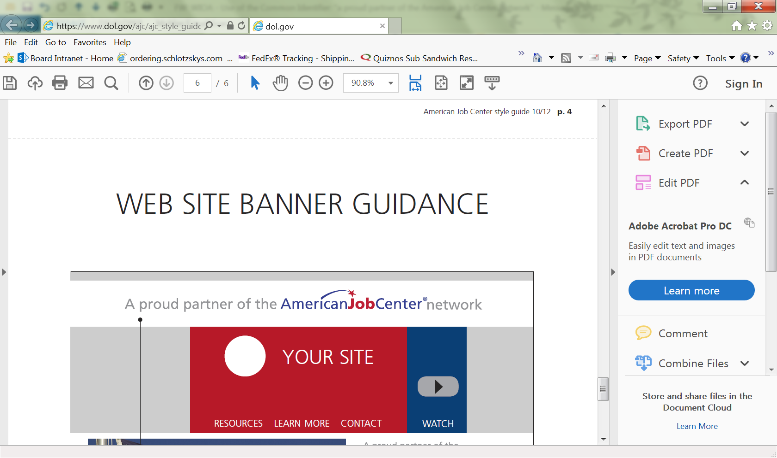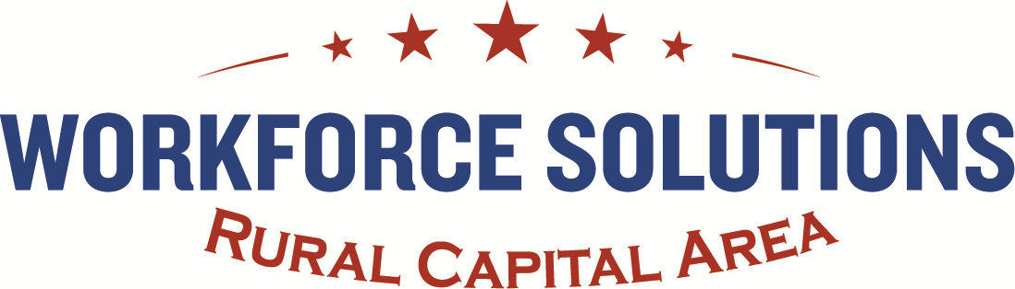

**Strategic & Operational Plan**



**PY 2017 – PY 2020**

701 E Whitestone Blvd, Suite 125

Cedar Park, Texas 78613

Phone: 512.244.7966

Fax: 855.326.3055

www.workforcesolutionsrca.com

Workforce Solutions Rural Capital Area is an Equal Opportunity Employer/Program. Auxiliary Aids and Services are available upon request to individuals with disabilities. Relay TX: 711 or 1-800-735-2988 (Voice) or 1-800-735-2989 (TDD).

Table of Contents

**Part A. – Strategic Elements**

• Board’s Vision 2

• Board’s Strategy 5

• Regional Analysis 10

• In-Demand Industry Sectors & Occupations 17

• Target Occupations 21

• Knowledge & Skills Analysis 23

• Regional Workforce Analysis 24

• Workforce Development Analysis 32

**Part B. – Operational Elements**

• Workforce Development System 33

• Board’s Partnerships 36

• Target Population Strategies 40

• Local Area Strategies & Services 41

• Local Workforce Investment Activities 46

• One-Stop Delivery System 47

• Adult & Dislocated Worker Employment Assessment 51

• Workforce Investment Activities 54

• Youth Workforce Investment Activities 56

• Secondary & Postsecondary Education Programs 60

• Transportation Services 61

• Maximizing Service Delivery 61

Table of Contents Continued

• Coordination of WIOA Title I & II Activities 63

• Executed Cooperative Agreements 64

• Disbursal of Grant Funds 64

• Sub-Grants & Contracts for WIOA Title I 64

• Local Levels of Performance 66

• Performance 66

• Training Services 68

• Integrated Technology 68

• Priority Assistance 69

• ITA Limits 70

• Youth Programs 71

• Apprenticeship Programs 74

• Apprenticeship Texas Strategy 74

**Part C. – Public Comment 75**

# **Local Workforce Development Board Planning Guidelines Program Years 2017–2020**

**Introduction**

Under the Workforce Innovation and Opportunity Act (WIOA) §108, each Local Workforce Development Board (Board) is required to develop and submit to the state a comprehensive four-year plan (Local Plan) that identifies and describes policies and procedures as well as local activities that are in line with the State Plan. This Local Plan must be developed openly and be available to the public for comment for 30 days, particularly to members of the business and educational communities as well as various other labor organizations. Along with submission of the Local Plan to the Texas Workforce Commission (TWC), the Board must submit all public comments of disagreement with the plan to TWC.

At the end of the first two-year period, the appropriate chief elected officials and the Board review the local plan and prepare and submit modifications to reflect changes in the labor market and economic conditions, factors affecting the implementation of the plan, changes in financing, changes to the structure of the Board, and/or the need to revise strategies to meet local performance goals.

## **Part A: Strategic Elements**

The strategic elements of the Local Workforce Development Board Planning Guidelines (Guidelines) are as follows:

### *Boards’ Vision*

1. A description of the Board’s strategic vision to support regional economic growth and economic self-sufficiency. The description must include:
   1. goals for preparing an educated and skilled workforce, including youth and individuals with barriers to employment; and
   2. goals relating to the performance accountability measures based on performance indicators described in WIOA §116(b)(2)(A).

**Board Response:**

## **Mission**

Preserve our integrated, employer-driven workforce system by actively involving employers in workforce decisions that allows them to: identify labor and economic trends, define skills and training standards and hire high skilled workers, while simultaneously providing job seekers with information, advice, job search assistance, supportive services, and training in the employer identified industries and occupations so they will attain cutting edge skills that will lead to self-sufficient employment.

## **Vision**

Our employers will have a highly skilled and educated workforce and our residents will have the competencies, skills and education to become self-sufficient and live a quality life.

## **Values**

### **Commitment**

* We embrace our mission, vision and values.
* **Professionalism**
* We welcome diversity and treat everyone with respect, dignity and courtesy.

### **Quality**

* We have a passion for our customers and partners. We are self-critical, questioning and committed to providing accessible, accurate, complete and timely services.

### **Integrity**

* We are accountable, honest and trustworthy.

### **Leadership**

* We have the courage to lead change and shape the future.

### **Teamwork**

* We work better together. We share our ideas and talents to find the best solutions. We support and rely on each other. We value clear and open communication.
* We make everyone better.

Rural Capital’s mission, vision and values communicate and guide our efforts toward regional economic growth and family self-sufficiency. We are committed to planning and working collaboratively with all of our program partners, economic development corporations, chambers of commerce, independent school districts, regional universities and community colleges, training providers, employers and job seekers. We greatly value every partner’s contribution and are working very hard to ensure the smooth integration of our newest partners—Adult Education and Literacy (AEL) and Vocational Rehabilitation (VR).

1. Goals for preparing an educated and skilled workforce, including youth and individuals with barriers to employment.

Our primary customers are our employers. In our service area our employers have the greatest demand for middle-skill employees to fill middle-skilled jobs. These jobs require more than a high school degree but less than a four-year degree. While employment opportunities are continuing to grow in all industries except government, it is difficult to find qualified employees. Even though these jobs will lead to self-sufficiency and they offer advancement opportunities. As a result, middle skill jobs represent an important opportunity for our youth, individuals with barriers to employment, and our AEL customers. Our goal is to continue to convene working groups with our education and training providers, youth staff, vocational rehabilitation staff and workforce center managers to secure class-size training designed to meet the specific employer skills for each middle-skilled job. The specifically developed curriculum is delivered in our rural communities close to where our job seekers live and will work. Our goal is to take the training to our job seekers and we do not ask them to commute to the urban education centers. By focusing training on the Integrated Education and Training (IET) model we ensure cost sharing for training and support services among all partners. In addition to IET, our youth and individuals with barriers to employment are provided with work-based learning including internships, work experience, and subsidized summer employment accompanied by financial literacy classes.

1. Goals relating to the performance accountability measure based on performance indicators.

Our goal is to meet or exceed all of the measures. We have a well-established process for oversight of the performance measures which includes evaluating each performance measure on its own merit, identifying trends that might negatively impact our performance and correcting those negative trends before they impact performance. For the past two years we have been one of the Boards that have met or exceeded every one of our performance measures. We plan to continue to set our performance bar very high.

1. A description of the Board’s strategy to work with the entities carrying out the core programs and with the required partners to align resources available to the local area, to achieve the vision and goals.

**Board Response:**

The Board, Adult Education and Literacy, and Vocational Rehabilitation staffs have been working since February 2016 to ensure a smooth integration of these new program partners into our workforce centers so their resources are available to all center customers. Our workforce center contractor, ResCare, has provided management oversight of all center programs and services since 1997 and has long ago ensured Adult, Dislocated Worker, Youth, Temporary Assistance for Needy Families (TANF), Supplemental Nutrition Assistance Program (SNAP), Non-Custodial Parent (NCP), Employer Services (ES), Texas Veterans Commission (TVC) services and resources were used and are delivered seamlessly. By using two proprietary programs Steps to Employment (STEP) and Managed Activity Plan (MAP) ResCare staff determines the needs of the customer and matches the available resources in the center to meet the customer’s needs.

All of the partners have agreed to capture the opportunities provided by Texas Workforce Commission now serving as the administering umbrella for all WIOA core program partners to plan, implement, and continuously improve the partnership.

This strengthened partnership is more important than ever, since:

- Resources available to the partners are declining or remaining flat and no one program has sufficient resources to be able to achieve all that needs to be done;

- Many customers served have multiple-challenges to employment and need skills and credentials to get better jobs;

- Local employers confront increasing difficulties in finding the talent needed to meet the needs of their businesses;

- The Rural Capital Service Area is a very large geographic area with limited public transportation services and customer access to services must not be dependent on silo program locations requiring unreasonable travel; and

- Some performance expectations are now common to all partners and individual program partners will achieve greater success with an increased integration of services.

The Partners have agreed to implement a planning process (with significant involvement by the leadership and frontline staff of all Partners) to develop a partnership plan with strategies and tangible tools and procedures to more effectively share customers and services.

**II. The Partnership Vision, Goals, and Outcomes**

*The partners commit to work together to:*

1. Build a one-stop system of service delivery system with every service location Serving as an On-Ramp for All Partner Services;

2. Increase Customer Access to Comprehensive, Timely, Responsive, and Customized Services with a Focus on Individuals with Barriers to Employment;

3. Serve More Customers Effectively and Improve Customer Service (with Both External and Internal Customers) Through Cross-Program Referrals and the Implementation of Seamless, Integrated Service Delivery Strategies;

4. Identify Career Pathways (Responding to Industry Talent Needs) and Offer Customers the Opportunity to Obtain the Skills and Credentials Necessary to Find Better Jobs at Better Wages;

5. Enhance Employer Engagement to Build a Occupational/Skills Demand-Driven System, Improve Business Services, and Provide More Work-Based Learning Opportunities;

6. Align Individual Program Policies, Procedures and Processes (When Not Constrained by Program-Specific Law or Regulation) to Achieve Greater Partnership in Service Delivery;

7. Seek Practical Opportunities to Share Resources, Reduce Redundancies and Waste, and Make Integrated Service Delivery More Streamlined for Customers and Frontline Staff;

8. Strengthen Frontline Staff Relationships and System Affiliation, Offer Staff Training in Partner Services, and Provide Tangible, Helpful Tools to Facilitate Seamless Service Delivery; and

9. Support Partner Programs in Achieving Success with the Performance Indicators.

**III. Mutual Partner Promises**

*The Partners and All Partner Staff Promise To:*

1. Put the Customer First with the Focus on Individualized, Quality Customer Services and, Then, Seek Ways to Work Within Regulatory Requirements;

2. Follow-Through on Cross-Partner Referrals and Customer Connections and Do So on a Timely Basis;

3. Commit to Continuous Learning About All Partners’ Laws, Regulations, and Culture to Better Understand the Opportunities for Partnership and Linkages;

4. Recognize and Respect the Competencies and Constraints of Each Partner and Tap Their Expertise for System and Program Improvement;

5. Be Transparent and Honest and Listen for Opportunities for Agreement;

6. Say What We Will Do and Do What We Say; and

7. Exhibit Openness to Change and Seek Continuous Improvement in Service Delivery.

**IV. Partner Agreements to Share System Services**

*The Partners Agree To:*

1. Provide training to frontline staff in all program service locations to have a broad understanding of all partner program services and eligibility to increase customer access to system services;

2. Increase the promotion of system services through the inclusion of system services in customer orientations and including partner program links on individual websites;

3. Develop and distribute partner program fact sheets in all service locations so that more customers will know about the system services that are available;

4. Give appropriate levels of access for frontline staff to program partner customer databases (WIT, TWIST, and TEAMS) to permit staff to better serve customers being served by more than one program partner;

5. Share customer information (whenever possible and legal) to reduce the need for redundant information collection through adopting a cross-partner confidentiality policy and developing a standardized customer release form.

**V. Partner Agreements to Share System Customers**

*The Partners Agree To:*

1 Implement a standardized cross-partner referral process that:

* Increases the appropriateness and quality of referrals;
* Reduces redundant customer information collection;
* Provides clarity on who is the point of contact for referrals; and,
* Sets expectations for timeliness, follow-through, and feedback after the referral is made.

2. Help customers complete a basic WorkInTexas profile as the first step in the referral process to share basic customer data and to establish a WIT account that may be used as a platform to help customers find jobs in the service delivery process; and

3. Encourage co-enrollment across partner programs (when appropriate) to enhance the services received by customers and to provide these services through integrated case management.

**VI. Partner Agreements to Share Business and Job Finding Services**

*The Partners Agree To:*

1. Designate the Board’s Business Service Unit (BSU) to coordinate and provide business services on behalf of all partners, including job development, job matching, job posting, job fairs, and labor market information;

2. Register all partner job-seeking customers and post all job openings in Work-In-Texas (WIT);

3. Train all frontline partner staff in the effective use of WIT to increase quality job matches and identify job leads;

4. Provide information and technical assistance to partner staff in using local labor market information and “Rural Capital Careers Headlight” to help customers in career planning;

5. Ensure partners are continuously updated on the Center’s job finding workshops and recruitment events, so they may encourage their customers to attend.

**VII. Partner Agreements to Communicate, Build Strong Relationships, And Continuously Improve**

*The Partners Agree To:*

1. Develop a master email list of all partner staff to be used to update staff continuously on partner news, TWC WD Letters, and Center events;

2. Host at least one cross-partner, all staff event annually to strengthen relationships, provide cross-training, and develop partnership improvement strategies; and

3. Have partner program leadership meets quarterly to evaluate the partnership strategies, monitor Implementation on the Partnership Plan, and seek continuous improvement.

### *Economic and Workforce Analysis*

1. A regional analysis of the following:
2. The economic conditions, including existing and emerging in-demand industry sectors and occupations, as well as targeted occupations
3. The employment needs of employers in existing and emerging in-demand industry sectors and occupations

As appropriate, a local workforce development area (workforce area) may use an existing analysis, provided that it is recent and provides a current and accurate description of the regional economy.

**Board Response:**

**Profile: Rural Capital Area**

The Rural Capital Area has an overall population of 1,033,000 people and 273,000 jobs. The area has grown faster than the U.S.: The population grew 26% from 2010-2018 and job base grew 35%. The area’s population growth is primarily due to the migration of people into the area

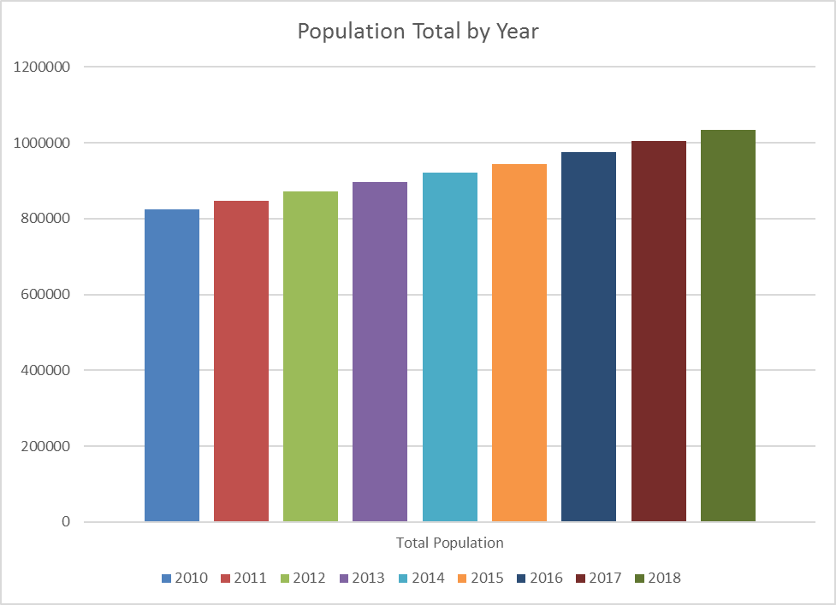

The Rural Capital Area’s population is 58.5% White, 29.5% Hispanic, 5.6% Black, and 4% Asian. The Rural Capital Area has a relatively younger population with a high concentration of families.

According to the Census, 21% of the Rural Capital Area’s population is children under 15 years old (versus 19% for the U.S.) and 28% of area residents are between the ages of 25 and 44 years old (versus 26% for the U.S.). As a result, the area has a lower concentration of residents over the age of 45.

The Rural Capital Area’s median household income has consistently been higher than the national average for the past decade and was 121% of the U.S. level in 2017.

The percent of overall population in poverty in the Rural Capital Area has remained under national trends over the past decade. Between 2010 and 2017 overall population in poverty in the Rural Capital Area fell from 10.5% to 10.2%.

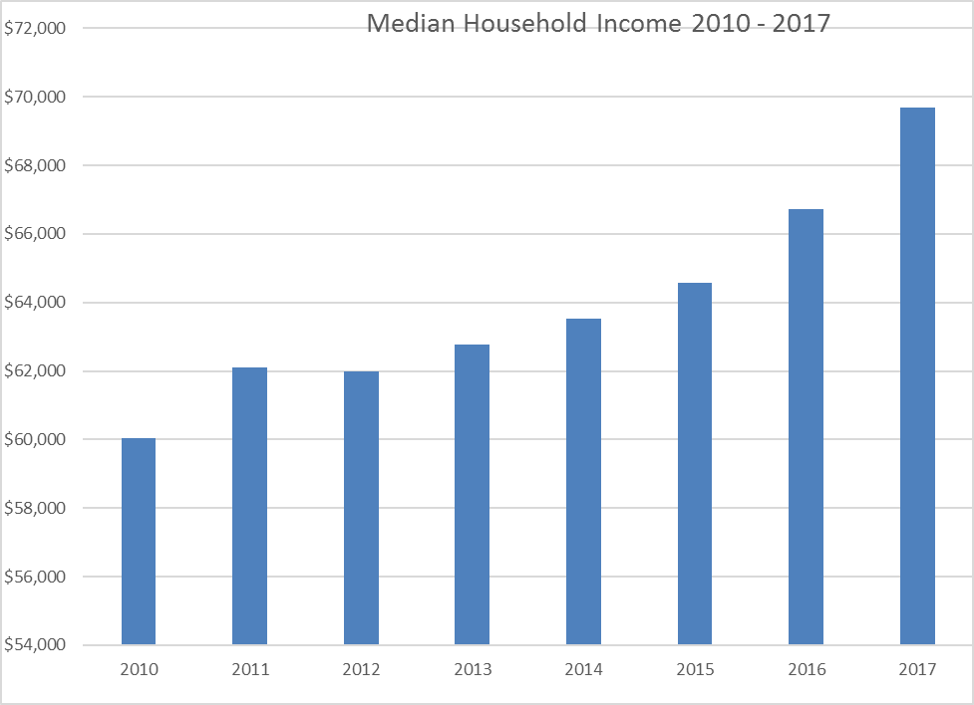

The Rural Capital Area’s economy has performed very well over the past decade, creating new jobs every year except 2009. The Rural Capital added 91,000 jobs from 2010 to 2018

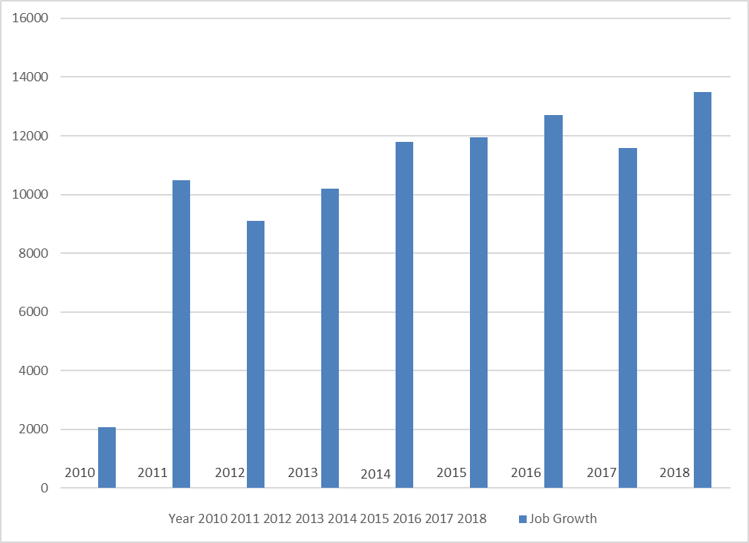

The Rural Capital Area unemployment rate has fallen from a peak of 7.3% in 2010 to 3.1% in 2018.  The area rate has been consistently lower than the U.S. rate.

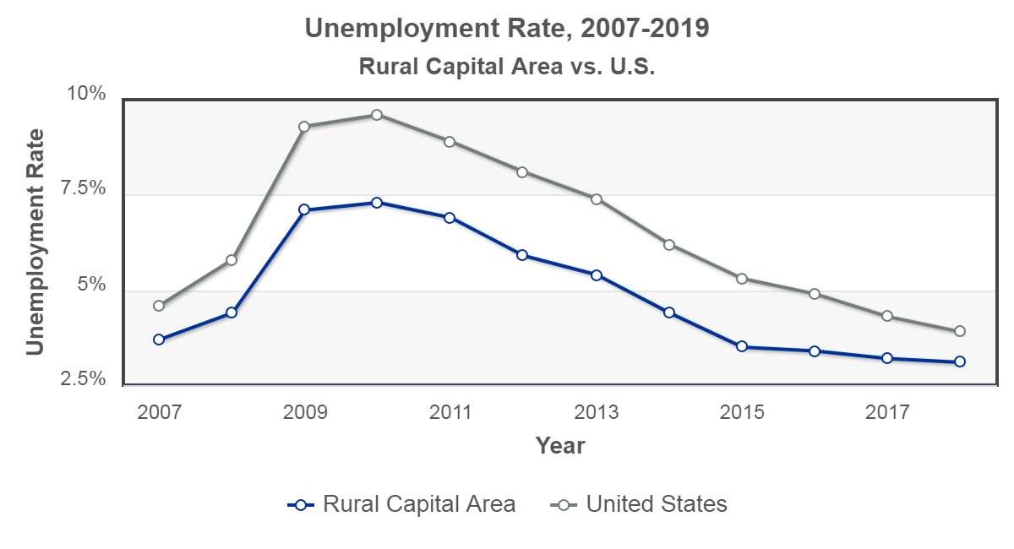

The largest industries in the Rural Capital Area are:

Retail, Educational Services, Accommodations and Food Services, Health Care and Social Assistance, Construction, and Manufacturing

Employment in all major industries has grown over the past 5 years.

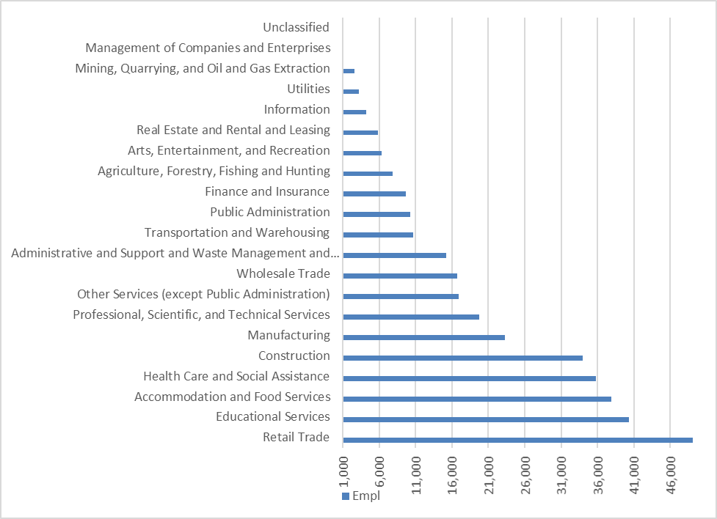

The area’s fastest growing salaries are in Manufacturing, Professional and Business Services, Natural Resources and Mining, Construction and Financial Activities.

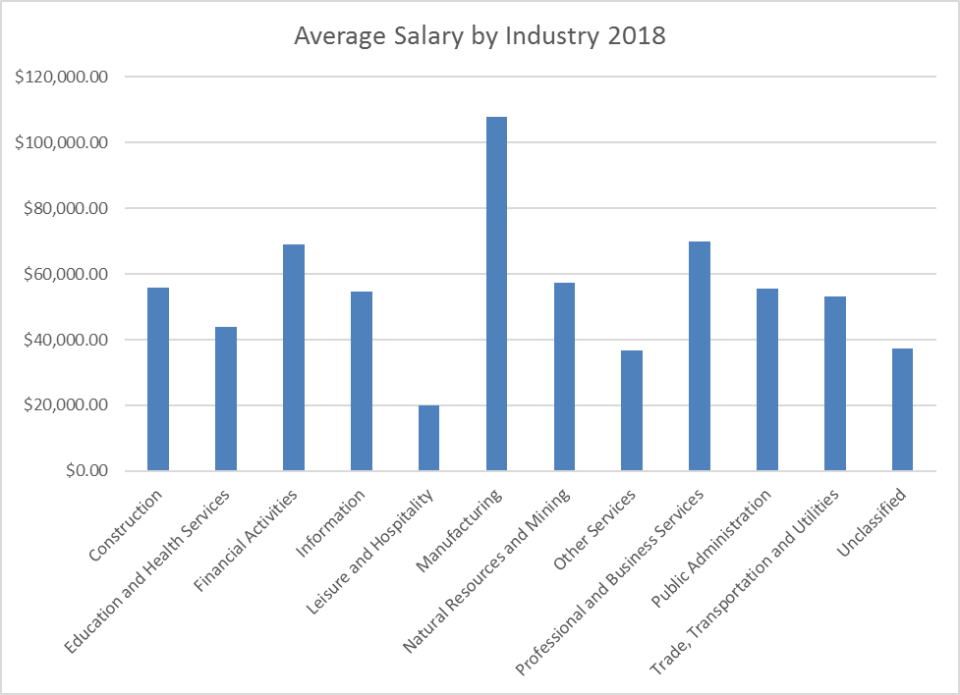

1. A list of the in-demand industry sectors and occupations.

**Board Response:**

**Profile: Industry Trends**

The Rural Capital Area employs 350, 900 people in a diverse range of industries.

The largest industries in the RCA are:

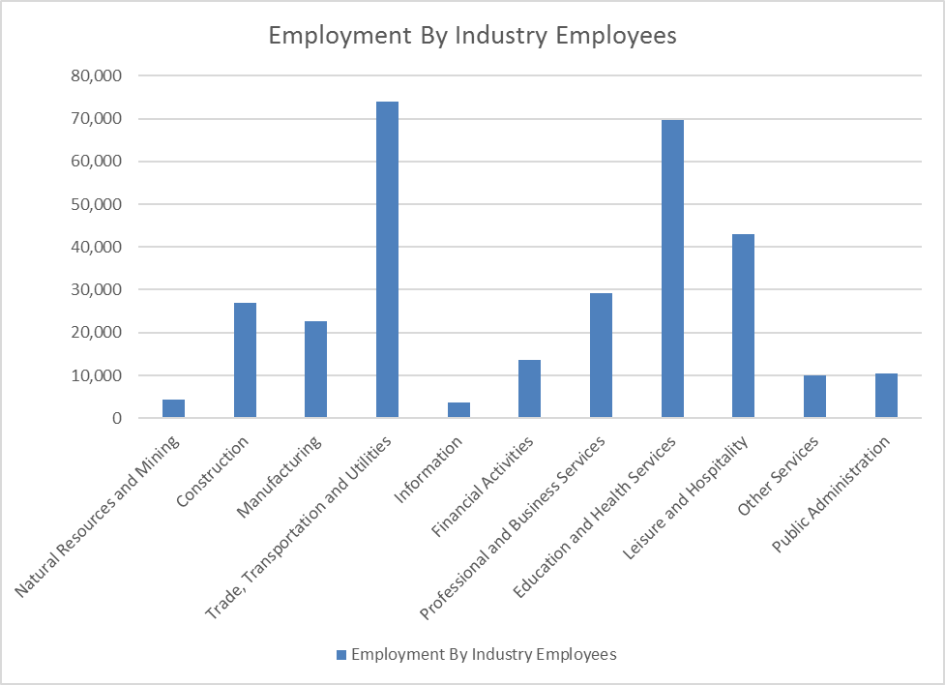

|  |  |
| --- | --- |
| ***Industry*** | ***% of Total*** |
| Natural Resources and Mining | 1.40% |
| Construction | 8.70% |
| Manufacturing | 7.40% |
| Trade, Transportation and Utilities | 24.00% |
| Information | 12.00% |
| Financial Activities | 4.50% |
| Professional and Business Services | 9.50% |
| Education and Health Services | 22.60% |
| Leisure and Hospitality | 14.00% |
| Other Services | 3.30% |
| Public Administration | 3.40% |

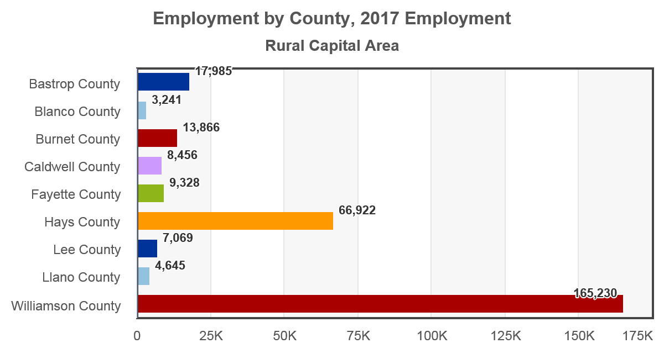

Employment is roughly proportional to population across the Rural Capital Area. Williamson County hosts the greatest number of jobs with 165,230 and 55% of regional employment. The next largest employment counties are Hays County with 22% of regional jobs and Bastrop County with 6%. Employment has grown in all counties between 2007 and 2017, but growth was greatest in Hays County (40.3%), Williamson County (40.2%), Bastrop County (35%), and Caldwell County (28.5%).

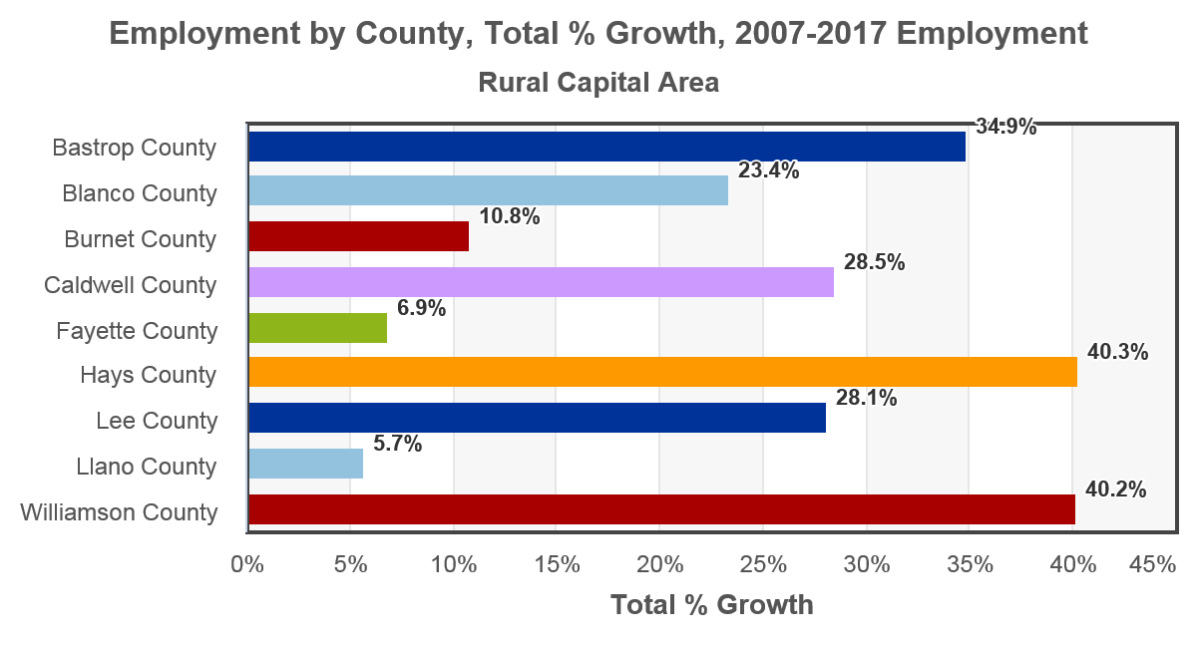

**FASTEST GROWING INDUSTRIES**

Employment is roughly proportional to population across the Rural Capital Area. Williamson County hosts the greatest number of jobs with 165,230 and 55% of regional employment. The next largest employment counties are Hays County with 22% of regional jobs and Bastrop County with 6%. Employment has grown in all counties between 2007 and 2017, but growth was greatest in Hays County (40.3%), Williamson County (40.2%), Bastrop County (35%), and Caldwell County (28.5%).



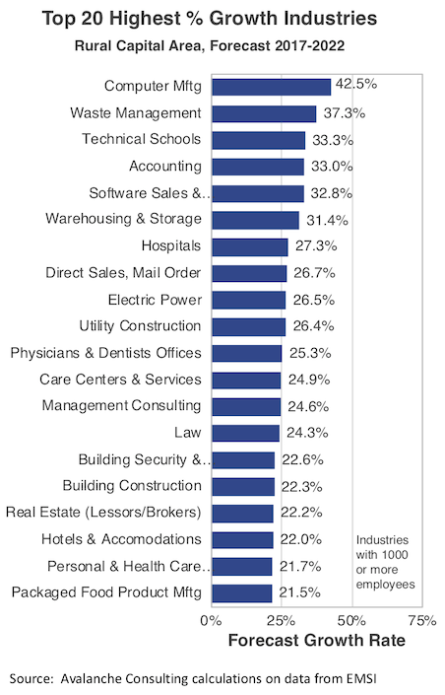

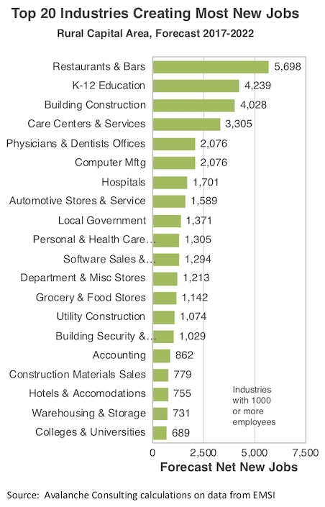

|  |  |  |  |  |  |
| --- | --- | --- | --- | --- | --- |
| **NAICS** | **NAICS Industry Title (Name)** | **Annual Average Employment 2014** | **Annual Average Employment 2024** | **Number Change 2014-2024** | **Percent Growth 2014-2024** |
| 6111 | Elementary and Secondary Schools, Public and Private | 28220 | 40550 | 12330 | 44% |
| 7225 | Restaurants and Other Eating Places | 25580 | 36830 | 11250 | 44% |
| 9993 | Local Government, Excluding Schools and Hospitals | 10930 | 13210 | 2280 | 21% |
| 4234 | Commercial Equipment Merchant Wholesalers | 8670 | 10900 | 2230 | 26% |
| 6221 | General Medical and Surgical Hospitals, Public and Private | 4410 | 5790 | 1380 | 31% |
| 6231 | Nursing Care Facilities, Skilled Nursing | 3330 | 4600 | 1270 | 38% |

|  |  |  |  |  |
| --- | --- | --- | --- | --- |
| **Rural Capital Demand Occupations** | | | | |
| **SOC** | **Occupational Title** | **Ave Emp 2014** | **Ave Emp 2024** | **Annual Openings** |
| 47-2031 | Carpenters | 3,434 | 4,444 | 147 |
| 31-1014 | Nursing Assistant | 5756 | 7286 | 306 |
| 39-9011 | Childcare Workers | 6965 | 8470 | 383 |
| 47-2061 | Construction Laborers | 9478 | 11850 | 453 |
| 43-4051 | Customer Service Representatives | 24021 | 28283 | 1082 |
| 31-1011 | Home Health Aides | 2636 | 3802 | 192 |
| 37-2011 | Janitors & Cleaners, Ex. Maids & Housekeeping Cleaners | 11838 | 14826 | 571 |
| 37-3011 | Landscaping & Grounds Keeping Workers | 7283 | 8874 | 308 |
| 43-9061 | Office Clerks, General | 29961 | 34154 | 1123 |
| 41-2031 | Retail Salesperson | 33105 | 39806 | 1960 |
| 43-6014 | Secretaries & Admin Assistants, Ex. Legal/Medical/Executive | 21618 | 24942 | 582 |
| 43-5081 | Stock Clerks and Order Filers | 11390 | 13354 | 597 |
| 25-9041 | Teacher Assistants | 6265 | 8577 | 415 |
| Effective: February 28, 2017 (PY 2017-2020) | | | | |

1. A list of the target occupations.

**Board Response:**

|  |  |  |  |  |  |
| --- | --- | --- | --- | --- | --- |
| **Rural Capital Area Target Occupations List** | | | | | |
| **SOC** | **Occupational Title** | **Ave Emp 2016** | **Ave Emp 2026** | **Change** | **2017 Mean Hourly Wage** |
| 49-3023 | *Automotive Service Technicians and Mechanics* | 4688 | 6157 | 1469 | $22.29 |
| 43-3031 | *Bookkeeping, Accounting, and Auditing Clerks* | 11398 | 16116 | 4718 | $18.48 |
| 15-1151 | *Computer User Support Specialists* | 7331 | 8637 | 1306 | $24.94 |
| 31-9091 | *Dental Assistants* | 3282 | 4425 | 1143 | $18.60 |
| 49-9051 | *Electrical Power-Line Installers and Repairers* | 728 | 873 | 145 | $27.14 |
| 47-2111 | *Electricians* | 4403 | 7263 | 2860 | $24.29 |
| 49-9021 | *Heating, Air Conditioning, and Refrigeration Mechanics and Installers* | 2393 | 4028 | 1635 | $18.41 |
| 53-3032 | *Heavy and Tractor-Trailer Truck Drivers* | 8601 | 13195 | 4594 | $18.45 |
| 49-9041 | *Industrial Machinery Mechanics* | 1243 | 1654 | 411 | $23.57 |
| 15-1122 | *Information Security Analysts* | 726 | 1095 | 369 | $51.77 |
| 51-9061 | *Inspectors, Testers, Sorters, Samplers, and Weighers* | 3282 | 4425 | 1143 | $19.88 |
| 29-2061 | *Licensed Practical and Licensed Vocational Nurses* | 3901 | 4497 | 596 | $21.72 |
| 51-4041 | *Machinists* | 1296 | 1824 | 530 | $19.99 |
| 49-9071 | *Maintenance and Repair Workers, General* | 8771 | 12779 | 4008 | $17.72 |
| 31-9092 | *Medical Assistants* | 3770 | 7125 | 3355 | $14.01 |
| 29-2071 | *Medical Records and Health Information Technicians* | 1384 | 1483 | 99 | $19.11 |
| 47-2152 | *Plumbers, Pipefitters, and Steamfitters* | 3961 | 7139 | 3178 | $21.97 |
| 43-6014 | *Secretaries & Administrative Assistants, Except Legal, Medical, & Executive* | 19455 | 24649 | 5194 | $16.57 |
| 15-1132 | *Software Developers, Applications* | 11938 | 16924 | 4986 | $51.19 |
| 15-1134 | *Web Developers* | 1929 | 2381 | 452 | $37.42 |
| 51-4121 | *Welders, Cutters, Solderers, and Brazers* | 2045 | 3154 | 1109 | $22.53 |

1. An analysis of the knowledge and skills needed to meet the employment needs of the employers in the region, including employment needs in in-demand sectors and occupations.

**Board Response:**

The Board has a standing Business Committee to provide oversight, recommendations and guidance on employer knowledge and skills needs in the 9-County area. Their primary responsibility is to ensure employer needs, as our primary customer, are met. We begin with an analysis of the industries and occupations that are driving the local economy. From that analysis we select the Target Industries and Target and Demand Occupations.

Training in an occupation selected for either the target or the demand occupations list will meet the knowledge and skills needs of our local employers. However, the process of identifying occupations for those lists is not a onetime event. We have new lines of business moving into our service area, their staffing, knowledge and skills needs are identified by Economic Development staff, Chambers of Commerce staff, community colleges or our other partners in the community, we modify the target and demand occupations.

In addition to working with board committees and community partners, the long-range projection data provided by LMCI is the most helpful tool in forecasting future employment levels within local industries and occupations. The estimates of current and projected employment by industry and occupation; identification of the industries and occupations adding the most jobs; and industries and occupations that are the fastest growing are the starting point for every long-range analysis with the board committees and partners.

We also consider the immediate or short-term needs of employers using Help Wanted Online and Wanted Analytics data. These tools allow us to examine actual online demand and to some extent demand history for occupations in our service area.

Chmura Economics & Analyticsand HEADLIGHT tools are used for intermediate analysis. Both of these tools aggregate data from many federal and state data producers, i.e., the Census Bureau, Bureau of Labor and Statistics. This data allows us to focus on employment trends for an intermediate period of time—usually a couple of years.

Once training is identified by the case managers, the Board focuses on short-term, (less than 12 months), continuing education programs that provide reasonable levels of knowledge and skills for our job seekers to gain employment. These knowledge and skill levels have been negotiated by the community college staff with the actual employers in the community who will be hiring the graduates. For most occupations on our target and demand lists the employers are requesting fewer in-class contact hours before hiring.

1. An analysis of the regional workforce, including current labor force employment and unemployment data, information on labor market trends, and educational and skill levels of the workforce, including individuals with barriers to employment.

**Board Response:**

# Unemployment Rate

The seasonally adjusted unemployment rate for the Rural Capital Area WDB was 3.2% as of January 2019. The regional unemployment rate was lower than the national rate of 3.9%. One year earlier, in January 2018, the unemployment rate in the Rural Capital Area WDB was 3.1%.

http://jobseq.eqsuite.com/US/ChartAxd.axd?i=dcp_afdcd77e1.png&_guid_=99625e01-3a14-4764-a991-4c52389fe0bf

Unemployment rate data are from the Local Area Unemployment Statistics, provided by the Bureau of Labor Statistics and updated through January 2019.

# Demographic Profile

The population in the Rural Capital Area WDB was 942,120 per American Community Survey data for 2013-2017.

The region has a civilian labor force of 481,744 with a participation rate of 65.8%. Of individuals 25 to 64 in the Rural Capital Area WDB, 34.9% have a bachelor’s degree or higher which compares with 32.3% in the nation.

The median household income in the Rural Capital Area WDB is $69,696 and the median house value is $203,397.

| **Summary1** | | | | | | | | | | | | |
| --- | --- | --- | --- | --- | --- | --- | --- | --- | --- | --- | --- | --- |
|  | **Percent** | | | | | | **Value** | | | | | |
|  | **Rural Capital Area WDB** | | **Texas** | | **USA** | | **Rural Capital Area WDB** | | **Texas** | | **USA** | |
| **Demographics** | | | | | | | | | | | | |
| Population (ACS) | — | | — | | — | | 942,120 | | 27,419,612 | | 321,004,407 | |
| Male | 49.5% | | 49.7% | | 49.2% | | 466,809 | | 13,616,977 | | 158,018,753 | |
| Female | 50.5% | | 50.3% | | 50.8% | | 475,311 | | 13,802,635 | | 162,985,654 | |
| Median Age2 | — | | — | | — | | 36.5 | | 34.3 | | 37.8 | |
| Under 18 Years | 25.0% | | 26.3% | | 22.9% | | 235,777 | | 7,213,117 | | 73,601,279 | |
| 18 to 24 Years | 10.0% | | 10.0% | | 9.7% | | 94,602 | | 2,752,064 | | 31,131,484 | |
| 25 to 34 Years | 13.1% | | 14.6% | | 13.7% | | 123,347 | | 4,002,129 | | 44,044,173 | |
| 35 to 44 Years | 14.5% | | 13.5% | | 12.7% | | 136,142 | | 3,705,119 | | 40,656,419 | |
| 45 to 54 Years | 13.1% | | 12.7% | | 13.4% | | 123,046 | | 3,494,999 | | 43,091,143 | |
| 55 to 64 Years | 11.4% | | 11.1% | | 12.7% | | 107,671 | | 3,036,278 | | 40,747,520 | |
| 65 to 74 Years | 8.0% | | 7.0% | | 8.6% | | 74,912 | | 1,915,612 | | 27,503,389 | |
| 75 Years, and Over | 4.9% | | 4.7% | | 6.3% | | 46,623 | | 1,300,294 | | 20,229,000 | |
| Race: White | 82.9% | | 74.6% | | 73.0% | | 781,044 | | 20,459,525 | | 234,370,202 | |
| Race: Black or African American | 5.5% | | 12.0% | | 12.7% | | 52,214 | | 3,286,950 | | 40,610,815 | |
| Race: American Indian and Alaska Native | 0.4% | | 0.5% | | 0.8% | | 3,522 | | 130,360 | | 2,632,102 | |
| Race: Asian | 3.8% | | 4.5% | | 5.4% | | 35,412 | | 1,236,852 | | 17,186,320 | |
| Race: Native Hawaiian and Other Pacific Islander | 0.1% | | 0.1% | | 0.2% | | 592 | | 23,531 | | 570,116 | |
| Race: Some Other Race | 4.2% | | 5.8% | | 4.8% | | 40,011 | | 1,580,393 | | 15,553,808 | |
| Race: Two or More Races | 3.1% | | 2.6% | | 3.1% | | 29,325 | | 702,001 | | 10,081,044 | |
| Hispanic or Latino (of any race) | 28.5% | | 38.9% | | 17.6% | | 268,388 | | 10,673,909 | | 56,510,571 | |
| **Population Growth** | | | | | | | | | | | | |
| Population (Pop Estimates)5 | — | | — | | — | | 1,011,224 | | 28,304,596 | | 325,719,178 | |
| Population Annual Average Growth5 | 3.3% | | 1.7% | | 0.8% | | 27,765 | | 447,261 | | 2,448,797 | |
| **Economic** | | | | | | | | | | | | |
| Labor Force Participation Rate and Size (civilian population 16 years and over) | 65.8% | | 64.4% | | 63.3% | | 481,744 | | 13,473,957 | | 161,159,470 | |
| Prime-Age Labor Force Participation Rate and Size (civilian population 25-54) | 83.5% | | 80.2% | | 81.6% | | 318,713 | | 8,945,583 | | 103,761,701 | |
| Armed Forces Labor Force | 0.1% | | 0.4% | | 0.4% | | 946 | | 91,081 | | 1,024,855 | |
| Veterans, Age 18-64 | 6.5% | | 5.2% | | 4.9% | | 37,878 | | 872,423 | | 9,667,749 | |
| Veterans Labor Force Participation Rate and Size, Age 18-64 | 80.4% | | 77.6% | | 75.8% | | 30,469 | | 677,079 | | 7,326,514 | |
| Median Household Income2 | — | | — | | — | | $69,696 | | $57,051 | | $57,652 | |
| Per Capita Income | — | | — | | — | | $31,670 | | $28,985 | | $31,177 | |
| Poverty Level (of all people) | 10.2% | | 16.0% | | 14.6% | | 94,564 | | 4,291,384 | | 45,650,345 | |
| Households Receiving Food Stamps | 6.9% | | 12.7% | | 12.6% | | 22,279 | | 1,196,016 | | 15,029,498 | |
| Mean Commute Time (minutes) | — | | — | | — | | 28.7 | | 26.1 | | 26.4 | |
| Commute via Public Transportation | 0.7% | | 1.5% | | 5.1% | | 3,041 | | 187,311 | | 7,607,907 | |
| **Educational Attainment, Age 25-64** | | | | | | | | | | | | |
| No High School Diploma | 9.7% | | 16.1% | | 11.4% | | 47,412 | | 2,287,734 | | 19,230,541 | |
| High School Graduate | 23.4% | | 24.7% | | 26.0% | | 114,735 | | 3,517,552 | | 43,784,920 | |
| Some College, No Degree | 23.8% | | 22.4% | | 21.2% | | 116,682 | | 3,183,316 | | 35,803,629 | |
| Associate's Degree | 8.2% | | 7.4% | | 9.0% | | 40,352 | | 1,051,162 | | 15,199,517 | |
| Bachelor's Degree | 24.0% | | 19.7% | | 20.5% | | 117,840 | | 2,808,143 | | 34,602,913 | |
| Postgraduate Degree | 10.8% | | 9.8% | | 11.8% | | 53,185 | | 1,390,618 | | 19,917,735 | |
| **Social** | | | | | | | | | | | | | | |
| Enrolled in Grade 12 (% of total population) | | | 1.6% | | 1.5% | | 1.4% | | 14,665 | | 398,124 | | 4,437,324 | |
| Disconnected Youth4 | | | 2.4% | | 3.0% | | 2.7% | | 1,276 | | 47,251 | | 456,548 | |
| Children in Single Parent Families (% of all children) | | | 26.1% | | 34.9% | | 34.5% | | 58,759 | | 2,396,094 | | 24,106,567 | |
| With a Disability, Age 18-64 | | | 9.2% | | 9.7% | | 10.3% | | 53,120 | | 1,613,122 | | 20,276,199 | |
| With a Disability, Age 18-64, Labor Force Participation Rate and Size | | | 50.7% | | 44.4% | | 41.4% | | 26,952 | | 716,525 | | 8,395,884 | |
| Foreign Born | | | 10.2% | | 16.9% | | 13.4% | | 96,453 | | 4,622,395 | | 43,028,127 | |
| Speak English Less Than Very Well (population 5 yrs and over) | | | 6.9% | | 14.1% | | 8.5% | | 61,089 | | 3,576,480 | | 25,654,421 | |

# Employment Trends

As of 2018Q4, total employment for the Rural Capital Area WDB was 350,907 (based on a four-quarter moving average). Over the year ending 2018Q4, employment increased 3.4% in the region.

cea_image_yoyEmployment

Employment data are derived from the Quarterly Census of Employment and Wages, provided by the Bureau of Labor Statistics and imputed where necessary. Data are updated through 2018Q2 with preliminary estimates updated to 2018Q4.

1. An analysis of workforce development activities in the region, including education and training.

**Note:** This analysis must include the strengths and weaknesses of workforce development activities and an evaluation of the effectiveness of programs and services. It must evaluate the Board’s capacity to provide workforce development activities to address the identified education and skills needs of the workforce. The analysis must include individuals with barriers to employment. The analysis also must address the employment needs of employers.

**Board Response:**

We have a great many community colleges and universities that are available to provide education and training in our 9-County area: Austin Community College, Central Texas College, Temple College, Texas State Technical College-Hutto, Blinn College, Victoria College, Alamo College, The University of Texas-Austin, St. Edwards’s University, Houston-Tillotson University, Texas Tech University, Southwestern University, and Texas State University. We work almost exclusively with the continuing education divisions in the community colleges and have had only a very few referrals to the universities. WIOA training funds are very limited so training programs are capped at a maximum of 12 months with the average training program lasting four months or less. Our immediate focus is on short term training in trades’ related occupations, but we are only able to provide limited entry-level knowledge and skills as defined by the employers in the service area. In addition to the activities and services required by WIOA, we offer numerous enhancements. Customers choose from an array of resources when visiting a workforce center or from on-line resources as described in Part B, question 2. Adult Education and Literacy IETs are helpful as a training opportunity for many of our customers who lack the academic skills to successfully complete a training program at institution of higher education. An IET may prepare an individual for further occupationally specific training or for immediate employment. The flexibility to schedule the days and hours for an IET is helpful. For example, the schedule that works for an IET with Blinn College in Schulenburg may be different for Austin Community College in Elgin. Rural Capital is tracking completion and entered employment rates for IET students. This information will be used for program evaluation and to set benchmarks for local performance measures.

## **Part B: Operational Elements**

The Operational Elements of the Guidelines are as follows:

1. A description of the workforce development system in the local area that identifies:
   1. the programs that are included in the system; and
   2. how the Board will support the strategy identified in the State Plan and work with the entities carrying out core programs and other workforce development programs, including programs of study authorized under the Carl D. Perkins Career and Technical Education Act of 2006, that support the strategy identified in the State Plan under WIOA §102(b)(1)E).

**Board Response:**

Our workforce development system is all about developing human capital designed to meet the future needs of our local employers. Board, center, and partner staff meet regularly to identify future employer needs, employee competencies and skill levels and then we decide which occupations for which we can best fill the skill gaps by using the program funds that are available from all the partners.

The workforce centers utilize the following strategies to screen and refer customers to enhanced services. Referrals to individual programs are made from those attending orientation and career planning sessions.

* **UI / Initial Claimants**

Unemployed customers are outreached and during the orientations customers learn about additional services available in the Workforce Centers.

* **WIOA**

Many customers receive orientation to the WIOA programs and other types of outreach. Trade affected customers, customers who are eligible for UI, those who have attended Rapid Response events, and those participating in Choices and SNAP E&T receive information about the WIOA program. Staff utilize these referral sources and follow up with customers individually to complete the screening process for intake and enrollment.

* **Rapid Response**

Individuals who will lose their employment due to downsizing or closure will also receive orientations to Workforce Center services, including WIOA programs. Orientations are conducted at the employer site, the Center or at a neutral location depending upon what the employer wants.

* **TAA / TRA**

Customers may learn about the TAA / TRA program during UI Profiling sessions, TAA orientations held weekly, Rapid Response events, directly from their employer or through outreach efforts at the state level. Interested customers attend either individual or group orientations at the Workforce Centers.

* **Services to Veterans**

Veteran’s Employment Representative staff identify appropriate veteran job seekers through the Work-In-Texas system. Customers are contacted individually, or may self-refer, for job search assistance, case management, and potential referral to the *Veterans Retraining Assistance Program* (VRAP), which offers up to 12 months of training assistance to unemployed Veterans, provides training towards an Associate’s Degree, Non-College, Degree, or Certificate that leads to a high demand occupation. BSU and Veteran’s Employment Representative staff also work to educate businesses concerning the availability of the Work Opportunity Tax Credit (WOTC), which offers a $4,800 credit for firms that hire qualifying veterans within one year of discharge or release from active duty, and up to $9,600 for those who have been unemployed for more than six months in the last year.

* **Customers With Limited English Proficiency (LEP)**

Texans with low literacy or poor English language fluency are identified through self-reporting, assessment by a Workforce Solutions staff member, and/or via the results of a literacy assessment test, such as the TABE.

When a job seeker identifies that he/she does not read, write or understand English very well staff may utilize several different options to aid the job seeker. First, in the instance of low English language fluency, the initial method of providing services involves using the language-interpreting service to communicate more fully with the job seeker. Once the formal method of communication has been established, staff commence with identifying the best course of assistance. Staff utilize partnerships with local Adult Education providers, such as the Literacy Council of Williamson County and Community Action Inc. our AEL provider, to provide low or no-cost ESL classes. As budget allows, staff may also refer the job seeker to funded ESL courses at a local community college or proprietary schools.

* **Customers Who Are Physically or Mentally Challenged**

Customers who are experiencing physical or mental challenges that have been unable to find work will be served through the Workforce Centers. The resource rooms have several types of adaptive equipment available, and Workforce Center staff work in conjunction with local advocacy groups, the VR, Department of Aging and Disability Services (DADS) and local MHMR agencies.

Each orientation emphasizes the benefits of quick attachment to the labor force with the advantages of job retention and career advancement. Center staff explain the available center services, conduct intake interviews to assist customers in determining the level and scope of services needed and identify any accommodations or supports needed to assist the customer in achieving employment success.

Center staff are cross-trained in providing basic services to universal customers. Talent Engagement Specialists work with program staff to learn each program in order to refer job seekers to appropriate enhanced services. Integration and referrals with Adult Education and Literacy and Vocational Rehabilitation started in early 2016 and has advanced to the point where all partner staff are familiar with the services of each of the core partners. We have started to integrate Adult Education and Literacy and Vocational Rehabilitation staff into the workforce centers and will continue that effort as space and funding allow. There is great excitement between all the partners to have this opportunity to better serve our customers.

The Board is committed to supporting the strategies in the State Plan including strengthening and expanding all of our existing and developing partnerships in order to serve our customers even better. The opportunities provided by the adoption of the Workforce Innovation and Opportunity Act and the Texas Workforce Commission, now serving as the administrative umbrella for all WIOA core program partners, allows us to plan, implement, and continuously improve services and performance for all program partnerships.

WIOA gives us new opportunities for the Board and Career and Technology Education (CTE) to work together to prepare individuals for careers that meet employer skill needs—specifically targeting STEM and middle-skilled jobs. The Board supports the State Plan by:

* identifying career pathways (responding to industry talent needs) and offering customers the opportunity to obtain the skills and credentials necessary to find better jobs at better wages
* enhancing employer engagement to build an occupational/skills demand-driven system, improve business services, and provide more work-based learning opportunities
* align individual program policies, procedures and processes (when not constrained by program-specific law or regulation) to achieve greater partnership in service delivery—working side-by-side with our isd and seven community college partners.
* seek practical opportunities to share resources, reduce redundancies and waste, and make integrated service delivery more streamlined for customers
* provide access to headlight and career headlight to improve access to up-to-date labor market and career information aligned with career pathways and occupational areas of study
* assigning board staff to serve on isd education advisory committees and acctech (guiding council for articulated credit) at acc
* assigning business service and youth career staffs to work with isd, business and industry, edc and coc staffs on youth career fairs
* providing teacher internships with industries—designed to improve teacher knowledge of industry skills needed in stem and middle-skilled careers
* support partner programs in achieving success with the performance indicators

1. A description of how the Board will work with entities carrying out core programs to:
   1. expand access to employment, training, education, and supportive services for eligible individuals, particularly eligible individuals with barriers to employment;
   2. facilitate the development of career pathways and co-enrollment, as appropriate, in core programs; and
   3. improve access to activities leading to a recognized postsecondary credential (including a credential that is an industry-recognized certificate or certification, portable, and stackable).

**Board Response:**

Every person that walks through the door, regardless if they are TANF, SNAP, UI Claimant, or general job seeker, will be provided a comprehensive array of services that includes **ResCare Career Pathway™** assessments, **ResCare Academy™**, and **Roadmaps to Success©** workshops in addition to case management and essential forms of support, such as housing, healthcare, transportation, legal assistance, clothing, and a wide range of counseling as appropriate for their respective programs. As we do with all of our customers, RWS administers detailed assessments to the target populations listed below, allowing us to determine immediate and long-term needs and set internal goals that act as mile markers on the individual’s career pathway. Our established relationships with support service and training providers throughout the area will ensure that job seekers have access to the services required to maximize the opportunities for participation in program services.

**Low Income Adults/Choices (TANF) Recipients** – We develop realistic IEPs that include short- and long-term goals, and assistance in education and financial planning that will result in higher wages and increased productivity. Our service plan for low income/Choices (TANF) recipients includes collaboration with local businesses who have entry-level jobs; identification of workers whose current skills are unsatisfactory to maintain self-sufficient employment; and provision of information to local low-income neighborhood associations and community centers. Our team ensures this population gains work-readiness skills through work experience, training provided through partners, online training through **ResCare Academy™**, and job readiness facilitation through our proprietary **Roadmaps to Success©** curriculum.

**SNAP Recipients –** During the required participation period of these job seekers, we offer daily support in our Resource Rooms for supervised and supported job search. We provide registration in WIT, resume development, initial and new job leads, assisted job search, and application as job search continues. We will encourage development of job skills through our free **ResCare Academy™** classes and completion of GED and AEL classes through local partners.

**Individuals with Disabilities** – As a company, ResCare works with individuals with disabilities as a core population through all three of ResCare’s lines of business: Workforce Services, Residential, and HomeCare. ResCare Workforce Services (RWS) will work with TWC Vocational Rehabilitation (VR) to help place their participants and with businesses to assess openings within their business, providing information about hiring job seekers with disabilities, and ensuring individuals are placed in the right situation to succeed. We build this platform through strong partnerships working with agency and program partners and by providing equipment and resources in our Centers designed specifically to assist identified needs for our non-hearing, non-speaking, or blind job seekers and targeted hiring events for workers with disabilities.

**Ex-Offenders** – Our team will work with probation, parole, and detention centers such as the United States Probation Office and the Texas Department of Criminal Justice, to register these job seekers in WIT, provide support during job search, enroll this population in programs as eligible, and provide support throughout program participation. Every program we operate could includes individuals with criminal records, even though funding does not target these populations.

**NCP** – Job seekers will be identified by the Office of the Attorney General and ordered into the NCP program by the Child Support Judge. The goal of the program is to reduce jail time and increase the amount and timeliness of child-support payments through intensive job search and employment retention programming. A Talent Development Specialist completes an assessment, develops an IEP, and discusses the services available in the Workforce Centers, similar to Choices and SNAP Center services orientation.

**NDWG** – ResCare has operated National Dislocated Worker Grant (NDWG) programs in the Board area. We understand the restrictions on this funding and how to have successful completions when there are large unexpected layoffs and significant job losses related to disasters and other emergencies.

**Veterans** – RWS works with veterans to help translate military skills and experiences into civilian terms that businesses understand. By targeting veterans, we can address multiple areas of diversity as this population also includes individuals from every other target population. We will provide all veterans with priority services. We will work closely with veteran-serving agencies and organizations such as Texas Veterans Commission (TVC), the American Legion, Veteran of Foreign Wars (VFW) chapters, and National Guard units to ensure veterans are aware of available services. We will provide talent development to veterans for intensive and support services through possible skill upgrades and/or work experience opportunities. We will participate throughout the year and in cooperation with Board hiring events and educational events aimed at making veterans aware of available services.

**UI Claimants** – We will ensure these job seekers are connected quickly to businesses through close collaboration with the Business Services Unit (BSU). **Resume assistance**aids these job seekers to update their resume and WIT, and **Supply & Demand Portal** aids in quickly connecting job seekers to industry businesses. Our team will be committed to providing a level of service to UI Claimants that will assist them to move back to full employment as quickly as possible. Our standard procedures for service to UI claimants or potential claimants include:

* Any visitor to our Center requesting information about filing for unemployment will not only receive this assistance, but will also be registered on that first visit in WIT. The opportunity will also be offered to complete a resume through WIT, and if appropriate, a professional resume.. They will be encouraged to register for **ResCare Academy™** and consider immediately taking classes that will help them develop additional skills and/or refresh their computer skills, customer service skills, and job search/interview skills. All of these job seekers will be offered at least two job leads before leaving the Center.
* UI Claimants identified as high risk will be outreached by letter and invited into the Center for the Orientation to Workforce Services that their continued UI eligibility mandates.
* Same day registration into WIT, completion of a resume, development of a detailed, personalized IEP with our workforce professional’s guidance, and receipt of at least two appropriate job leads will be a required part of the orientation appointment.
* UI claimants will be encouraged to return regularly or to call for additional assistance throughout their job search and are asked to please let us know when they get a job.
* UI claimants will be informed of the mandate that they contact us within three weeks but will also be encouraged to stay in close contact and to return to the Center for additional job leads and assistance in job search, interview preparation, and online application skills. They will also be informed that we will be contacting them every two weeks after this period until they get a job.
* At each contact their IEP will be updated and activity documented.

**Individuals with Literacy/Language Barriers** – Our team, and our AEL provider, will work with local GED programs and English as a Second Language providers, and make **ResCare Academy™** and **GED Academy** tools available to GED students at no additional cost. We will also provide career introduction and planning services and programs on campus for these GED students who may want/need to complete additional career training through our WIA/WIOA programs. All services in our Centers will be available in Spanish, and the team will be able to access Language Line services for those job seekers who need an interpreter for other languages.

**General Job Seeker** – We will provide all job seekers the tools they need to successfully obtain employment that leads to self-sufficiency. Job seekers will have access to, training through facilitated **Roadmaps to Success©** workshops and **ResCare Academy™**, and job matching, as well as through WIT and **Supply & Demand Portal**.

All center staff are trained in **ResCare’s Talent Delivery Model** which uses **STEP** (Steps to Employment Plan) and **MAP** (Managed Activity Plan) proprietary programs designed to enhance service delivery. All individuals entering a Workforce Center will benefit from thorough needs assessments and move through the program appropriately based on their assessment results and desired career trajectory. RWS will ensure all job seekers understand where they are at all times in the process and are aware of the next steps in their career pathway.

1. A description of the strategies for coordinating programs and services for target populations.

**Board Response:**

In our response to Occupational Elements Question #2--Target Groups—Low Income Adults, SNAP Recipients, Individuals with Disabilities, Ex-Offenders, NEG, NCP, Veterans and UI Claimants, we provided a detailed description of how services are delivered to each of the target populations. In addition, staffs meet regularly to reassess the services each program provides, and the Board has implemented a partnership agreement that has been signed by all partners.

***The Center Partners Agree To:***

Implement a standardized cross-partner referral process that:

* Increases the appropriateness and quality of referrals;
* Reduces redundant customer information collection;
* Provides clarity on who is the point of contact for referrals; and,
* Sets expectations for timeliness, follow-through, and feedback after the referral is made.

Help customers complete a basic Work-In-Texas profile as the first step in the referral process to share basic customer data and to establish a WIT account that may be used as a platform to help customers find jobs in the service delivery process.

Encourage co-enrollment across partner programs (when appropriate) to enhance the services received by customers and to provide these services through integrated case management.

1. A description of the strategies and services that will be used in the local area:
   1. To facilitate engagement of employers in the workforce development programs, including small employers and employers in in-demand industry sectors and occupations
   2. To support a local workforce development system that meets the needs of businesses in the local area
   3. To better coordinate workforce development programs and economic development
   4. To strengthen linkages between the one-stop delivery system and unemployment insurance programs

**Note:** This may include the implementation of initiatives such as incumbent worker training programs, on-the-job training programs, customized training programs, industry and sector strategies, career pathways initiatives, use of effective business intermediaries, and other business services and strategies designed to meet the needs of regional employers. These initiatives must support the strategy described above.

**Board Response:**

Workforce Solutions Rural Capital Area, through its Business Services Unit (BSU), brings businesses and job seekers together. We work with Unemployment Insurance (UI) claimants and assist customers that need specific help. We outreach and foster business relationships with employers by educating them on the availability of skilled job seekers in their area, obtainable tax credits, and the opportunity to participate in activities such as on-the-job training. The BSU maintains an “inventory” of available job seekers we have in Work in Texas in each county and the Employers in each county that do the most hiring. BSU staff make personal contact to the Chamber of Commerce’s and Economic Development Cooperative’s to build strong and continuing relationships with them.

**Internal Business Services**

Internal Business Services are provided by the Talent Engagement Specialist (TES), whose primary assignment is to work with Unemployment Insurance (UI) claimants, assist universal customers that need specific help, and assist employers within the center. Within this context, the TES performs the following tasks:

**UI Claimant Support**

Each week all TES staff receive a new Customer Tracking System (CTS) list which shows new UI claimants. The CTS database is a ResCare developed program that tracks the UI claimants’ job search progress within the first ten weeks of their UI period. The TES will:

* make initial contact with the claimant and provide WIT service(s) within 48 hours
* provide information on center services available to the claimant up to and including workshops
* provide job seeking tips along with job matches from WIT
* direct claimant to applicable orientations and workshops
* refer claimant to other program assistance where applicable
* review claimant Work-In-Texas.com application and suggests possible improvements to increase the potential for job match
* prepares center orientation material, including job search process and Employment Plan process
* look for a possible job development opportunity when there are no jobs matched in WIT; refer to BSU
* recommend other job search sites to maximize the claimants exposure in the job market
* makes contact every week to check on claimants’ job search progress, provide job search recommendations and encouragement, and document hires
* enter employment verification from UI claimants in WIT within 24 hours of notification

**Universal Customer Support**

Walk-in customers occasionally need specific assistance in their job search efforts. In these instances, a TES meets with these customers, determines their needs, and provides the appropriate assistance. Support includes similar activities as listed above in the UI CTS section.

TES staff members also provide significant in-house services to the business community. One of these is job posting support and monitoring. TES staff members review daily all new postings submitted directly to WIT by the business. During this activity, the TES will:

* Perform a quality assurance review of each new business posting assigned to the office,
* Run veterans first day job matches and send the matched job seeker notification of the match for follow up, (first 48 hours is veterans only) then run third day matches for the general job seeker population, run weekly matches for follow up,
* Follow-up weekly with employers on open postings,
* Provide weekly follow-up on close-pending postings,
* Assist employers that contact WSRCA offices by telephone for issues such as:
* Determine specific needs of customer,
* Set- up accounts for business in WIT or update existing accounts as appropriate,
* Talk business through the process of entering a posting themselves ,
* Enter job posting for the employer if they so desire,
* Explain details of job matching such as matching process, veteran’s preference, etc.,
* Discuss other services such as hiring events, etc.,
* Provide information on services outside of office such as TWC Tax Dept info, etc.,
* Assist employers with job fairs inside WSRCA offices.
* Assist employers that come into WSRCA offices in person – similar to those that call in above
* Refer employers to the Rural Capital Headlight website (<http://www.ruralcapitalheadlight.com/>) to provide Labor Market Information (LMI)
* Assist other Workforce staff with questions about job postings
* Coordinate/communicate with other Workforce offices regarding business/job posting issues

**External Business Services**

WSRCA staff work to deliver services and programs relevant and responsive to employers’ needs. Staff recognizes the importance of quality customer service beginning with the initial contact with a new employer. In order to “sell the system” and ensure continued usage, staff must provide quality, responsive services on a consistent basis. The primary goal of the Business Services Unit is to satisfy employers so they return and promote Workforce Solutions services to other employers.

External Business Services are provided by Business Services Unit (BSU). BSU staff engage employers, Chambers of Commerce, and Economic Development Cooperatives and provide direct support to them as appropriate. The BSU meets with employers at their place of business and offers a summary explanation of the general services available to employers, while detailing specialized services such as WOTC, subsidized employment, temporary statewide initiatives, OJT opportunities, and other board directed projects. As with all WSRCA staff, each BSU has specific state and local goals that must be achieved through the performance of assigned responsibilities.

Support activities provided by the external BSU include:

* **Recruitment and Hiring Assistance**

BSU staff use WIT as a primary tool to search for qualified employees. By taking advantage of WIT job matching features and evaluating previous jobs, better candidates can be presented to the employer. Additionally, labor market research by the BSU gives the employer better insight to the local competition for employees and the pay scales that will increase hire chances for the employer.

* **Customized Job Postings**

Staff assists Employers in the creation of higher yield job postings. This is done by using knowledge of the local business market, the expectations of current job seekers, in-depth knowledge of how WIT works, use of industry key words, detailed understanding of the employer expectations, etc. All of these contribute to finding the best employee match in WIT.

* **Labor Market Information**

LMI provides key economic data about occupations and in-demand industries along with information about labor market trends, local economic conditions, future economic developments, and overall labor supply in the local area. The BSU will refer employers to the Rural Capital Headlight website (<http://www.ruralcapitalheadlight.com/>) for Labor Market Information (LMI). This is one component of our Business Services Unit Plan.

* **Facilities for Interviewing**

Staff arranges space for employer job fairs/hiring events in local offices. Additionally BSU coordinates space needs with employers if office space is either unavailable or inadequate.

* **Screening and Referring Qualified Applicants**

Staff can assist employers in a screening process; i.e., place jobs on level 2 or 3 in order to find an employee that closely matches the employer’s need.

* **Liaison for TWC Information and Services**

BSU staff can provide specific information regarding TWC publications and data such as *Just For Employers*, etc.

* **Business Seminars**

The TWC Commissioner for Employers sponsors annual employer seminars around the state. Employers are encouraged to attend at least one of these seminars in order to learn the nuts and bolts information on state and federal employment laws and how to deal with the unemployment claims and appeals process. The BSU staff provides information to employers about these sources of business information.

* **Tax Credit Information**

Staff can inform Employers of Tax Credit incentives such as WOTC and similar programs.

* **Fidelity Bonding**

This program delivers a unique bonding service that is not duplicated by any other program in the U.S. to secure the job placement of ex-offenders and other high-risk job applicants, it provides employers with a financial incentive to hire the hardest-to-place jobseekers.

* **On-the-Job Training**

On-the-Job Training (OJT) provides unique opportunities for participants who already possess some job-related skills and the knowledge to "learn as they earn". By participating in training as an employee, the participant not only acquires new skills and knowledge, but also receives the same wages and benefits as current employees.

* **Work Experience**

Staff will serve as Liaisons between Case Managers and Employers to place Eligible Job Seekers in an unpaid work sites in order to benefit both the Employer and Job Seeker. This service will also include subsidized work experience for the Choices program.

* **Rapid Response Service**

At the Board’s direction, the Business Services Unit (BSU) and center staff coordinate with the employer where rapid response services are being provided to provide on-site workshops and job search. Beyond mere presentations of Workforce Center services, the BSU connect affected job seekers to the Texas Workforce Network in order to speed their transition to new employment or, when appropriate, training. By leveraging and localizing center activities to the employer site, the BSU acclimatizes job seekers to our job search systems and reduces their anxiety concerning unfamiliar processes and technical systems. With a sense of familiarity created, more job seekers would more effectively participate and utilize our offices, equipment and systems at their option.

1. An explanation of how the Board will coordinate local workforce investment activities with regional economic development activities that are carried out in the local area and how the Board will promote entrepreneurial-skills training and microenterprise services.

**Board Response:**

The 9-County region must continue to make progress in ensuring our regional populations are educated, prepared and trained for the highly technical, knowledge-based careers our EDC partners are recruiting to the area. With the accelerating transition to more highly innovative industry clusters, the entire region must bridge the skill gaps between production-based and information age-based skill sets. To drive the economy forward, the region’s workforce will require significantly different and higher levels of education and training than ever before. The Board continually hears from Chambers, EDC’s, HR Directors and small business owners that they find it difficult to fill key positions. Many of the business in our service area have or are planning to expand their operations within the next 24 months, and the difficulty of finding top talent is compounding as employers are increasingly struggling to find workers who possess the necessary skills to fill job openings. Unfortunately, this regional skill gap is projected to grow as the EDC’s continue to recruit larger employers with even greater demand for skilled workers.

To meet some of these skills needs the Board, community colleges, AEL and VR have been working with EDC partners and employers to provide customized skills training for both the employers’ incumbent and new hire employees. This year we have developed our first High Demand Job Training Grant with a rural EDC and are providing matching funds training in hardest to fill trades jobs. The BSU staff hosts targeted job fairs, while the Board staff participates in business recruitment, retention and expansion efforts of both the EDC and CoC staffs to ensure training is targeted at the current and future needs of the employers.

The Board has a great relationship with the Texas State University Small Business Development Center. The SBDC has a great understanding of the opportunities, needs and challenges in our local economies but more importantly they have a trusted history of developing successful entrepreneurs. With offices in Round Rock and San Marcos they are accessible during regular business hours or by appointment to work with existing and startup small businesses. They provide assistance during every phase of the business life cycle and their counselling, training, and research is provided at no cost to the customer. The Board and the SBDC have established a two-way referral with the Board providing skills training, targeted job fairs, or other employer services that are available from our business services staff.

1. A description of the one-stop delivery system in the local area, including explanations of the following:
   1. How the Board will ensure the continuous improvement of eligible providers and how providers will meet the employment needs of local employers, workers, and job seekers;
   2. How the Board will facilitate access to services provided through the one-stop delivery system, including to remote areas, through the use of technology and other means;
   3. How entities within the one-stop delivery system, including the one-stop operators and the one-stop partners, will comply with WIOA §188, if applicable, and with applicable provisions of the Americans with Disabilities Act of 1990 regarding the physical and programmatic accessibility of facilities, programs and services, technology, and materials for individuals with disabilities, including providing staff training and support for addressing the needs of individuals who have disabilities; and
   4. The roles and resource contributions of the one-stop partners.

**Board Response:**

The Board has monthly management meetings to review Monitoring findings and observations of ResCare performance and progress toward the attainment of Board enhanced performance measures included in the contract. ResCare also has an internal quality management program designed to ensure continuous improvement.

**ResCare Workforce Services Quality Management System (QMS)**

The quality improvement process uses a ‘systems’ approach to improving the quality of service delivery by providing a standard method for the creation, evaluation and control of customer service systems that are compliant with ISO 9001 – Quality Management Systems principles. With expert assistance from our ResCare Workforce Services Corporate offices, the establishment and maintenance of this system focuses on the following:

1. Planning of Service Delivery

2. Control of Service Delivery

3. Operating Under Controlled Conditions

4. Improvement Projects, and

5. Improvement Tools

Upon the establishment of any customer service delivery system or procedure, the system’s continuous improvement will be undertaken with each contract year cycle (or more frequently as required) by following the 7 improvement steps of ResCare Workforce Services QMS:

**PLAN**

1. Determine Project Charter

2. Describe Current State

3. Determine Root Causes

4. Develop Solutions (Test as Needed)

**DO**

5. Implement Solutions

**CHECK**

6. Evaluate Solutions

**ACT**

7. Standardize Solutions

The intent of this systems approach is the assurance that the evolving needs of both workforce services participants and employer customers are revisited and identified so that positive adjustments can continually be made to our methods of service delivery.

**Quarterly ‘Best in Class’ Reviews**

A primary evaluation tool that is used by QMS to review the status of all customer service delivery systems (and system supports) is ResCare Workforce Services Best in Class© Review and Report. This invaluable instrument, which has been tailored to the requirements and scope of Workforce specifications, is performed quarterly during each contract year. This instrument helps to clearly identify areas of possible or needed improvement in both our organizational and service delivery system structures & processes.

**The WSRCA Intranet – A Performance Briefing Book**

ResCare continues to enhance methods of ‘operating under controlled conditions’ by redeveloping our local intranet to include not only defined requirements, flow charts, standard operating procedures (SOPs) and work instructions, but also performance results and tracking data. The idea behind this effort is that each supervisor and manager will be able to use this compiled information as a reference source and staff training manual. Rather than simply providing a notebook of important information, ResCare Workforce Services will continue to use the intranet as the ‘Briefing Book’ so that this information will be available to all staff at their ‘point-of-use’.

**Training Providers on the ETPS**

Every year Board staff analyze performance data of participants we have sent to training. These analyses are conducted for all training program completers:

• Completion rate

• Employment rate in related occupation at 1 Year

• Percentage of individuals who obtain unsubsidized employment

• Wages at placement in employment

• Retention rate in unsubsidized employment at six months after employment

• Wages at six months after employment

• Rate of licensure

• Cost per participant

Upon conclusion of these analyses the Board staff determine if performance, employer feedback and cost per merit continuation in the ETPS. The results of the analysis are reviewed.

**REMOVAL OF TRAINING PROGRAMS AND PROVIDERS FROM THE ETPS**

A training program that fails to meet the required levels of performance or cost per is removed from the ETPS.

**Access to Services**

The Board has three full-service workforce centers—Williamson County (Round Rock), Bastrop County (Bastrop) and Hays County (San Marcos). We have five rural workforce centers—Burnet County (Burnet), Caldwell County (Lockhart), Fayette County (LaGrange), Lee County (Giddings) and Llano County (Llano). Workforce center services for Blanco County are provided out of the Hays County (San Marcos) workforce center.

In addition to our physical service delivery locations the Board provides web-based information on services available to customers—i.e., business services, job seeker services, child care services, labor market information and a link to Work-In-Texas so both employers and job seekers can self-serve.

**Adaptive Equipment and Services**

Board and ResCare staff conduct annual training on WIOA 188, the Americans with Disabilities Act and proper use of accessibility software and hardware. Board monitoring and QA staff conduct annual accessibility reviews to improve or correct accessibility barriers for individuals with disabilities.

ResCare Workforce Services provides customers equal opportunity to access all facilities, programs and services without regard to race, color, religion, gender, marital status, age, national origin, color, disability, political affiliation, veteran status or belief. We manage and operate the Rural Capital Area Workforce in compliance with EO and ADA requirements.

* **Minimum Accessibility Standards**

In order to comply with minimum accessibility standard drafted in March 2016, the array of adaptive equipment and services provided for customer use as been expanded in order to assure full accessibility to all available programs and center services. The following is list of adaptive strategies used by contractor staff in each office to assist customers requiring accommodation:

* + JAWS Screen Reading Software
  + MAGic Screen Magnifier Software
  + Microsoft Windows Magnifier
  + Microsoft Windows Narrator
  + Microsoft Windows On-Screen Keyboard
  + Purple Video Interpreting Service (VRI)
  + Purple P3 Video Relay Service (VRS)
  + MAGic Large Print Keyboards
  + BigTrack Trackball Mouse(s)
  + Chattervox Voice Amplifiers
  + Large Button VOIP Hearing Aid Compatible Telephones
  + TTY Telephones (Bastrop, Round Rock, & San Marcos Offices)
  + Bi-Level Adjustable Height Workstations
  + One-On-One Staff Assistance
  + Staff “Notetakers”
  + Staff “Readers”
  + Bilingual Staff Available (*Spanish* – Bastrop, Cedar Park, Giddings, Lockhart, Round Rock, and San Marcos Offices)
  + Language Identification Cards
  + Telephonic Language Interpreting
  + In-Person Sign-Language Interpreting

**Roles and Resource contributions of Partners**

ResCare has systematically worked to develop trust and a team spirit among center partners that promotes integration and cooperation from staff and partners. The helpful, accurate, and honest flow of information from management to and among staff is crucial to successful integration and alignment of goals amongst center partners. Supervisor and/or site meetings are held monthly or more frequently to disseminate performance and program information to staff and to promote dialog among staff members about changing service delivery and problem resolution. Information and orientation meetings are held to inform and connect staff facing transition into a more integrated service model and to apprise all staff of these changes.

Staff training opportunities continue to become more integrated. Topics such as FMLA, Sexual Harassment, ADA Compliance, Violence in the Workplace, Communication, Anger Management, Destructive Behavior and Problem Solving are a few of the modules staff are requested to review. The training program is an innovative computer-based system that guides and engages staff and customers in real workplace scenarios and situations.

Each new staff member, including partner staff, receives an intensive New Employee Orientation that covers workforce center operations, customer service, information systems, and other topics. The orientation also introduces new staff to the WSRCA, and ResCare Workforce Services management system, and all of the tools available to each Workforce Center staff member, such as the intranet, programmatic procedures, quality assurance, monitoring tools, etc.

1. A description and assessment of the type and availability of adult and dislocated worker employment and training activities in the local area.

**Board Response:**

**Basic Career Services**

Any customer entering the workforce center for the first time will receive basic career services. Basic career services include:

* Outreach (including worker profiling), intake and orientation to information and other services available in the workforce system
* Preliminary needs assessment
* Job search and job placement assistance, including the provision of information on nontraditional employment and in-demand industry sectors and occupations for job seekers
* Referral and coordination with other programs and services within and outside of the workforce system
* Provision of workforce and local, regional, state and national labor market information (LMI) including:
* Job vacancy listings
* Job skills needed to obtain vacant positions
* Information on demand occupation earnings, skill requirements and opportunities for advancement
* Information and assistance for filing unemployment insurance (UI) claims
* Work In Texas (WIT) registration
* Job search, job referrals (self or staff assisted). Placement assistance and where appropriate career counseling.
* Internet browsing related to career or training search
* Use of self-directed career exploration and other online resources.
* Referrals to other community resources
* Resume critique
* Use of resource room materials, equipment and information
* Use of Eligible Training Provider System (ETPS) for training provider information
* Group Sessions and Workforce Center Workshops
* Initial screening for referrals and information about activities leading to other Workforce Center programs.
* Referral to other staff or workshops.
* Other self-service and information services.

**Individualized Career Services**

If a customer is eligible for WIOA services and needs individualized career services to obtain or retain employment, WIOA Talent Development staff develops an Individualized Employment Plan (IEP) to include individual career services, a career pathway and occupational goals and steps to achieve these goals. Individualized career services may include:

* Comprehensive assessment using diagnostic testing for determination of skill level and in-depth interviewing
* Development of an individual employment plan (IEP) to identify employment goal, barriers and support service needs
* Short term prevocational services defined as training for:
  + Communication, interviewing, punctuality, personal maintenance, and professional conduct skills (referred to as “soft skills”) to prepare customers for unsubsidized employment; or
  + Non-occupationally specific skills in demand by employers such, as but not limited to, Microsoft Office, and introductory classes to industry clusters.
* Workforce preparation activities
* Financial literacy
* Computer literacy
* Internships, paid and unpaid work experience linked to a career pathway
* English language acquisition and integrated education and training programs (IET)
* Out of area job search and relocation assistance

**Training Services**

Training services may be available to customers who:

* Are unlikely to obtain or retain employment leading to a self-sufficiency wage;
* Are unlikely to obtain or retain employment with wages comparable to, or higher than, wages from previous employment; and
* Have the skills and qualifications to participate successfully in training services.

Workforce center staff determines which customers meet the criteria through interviews, assessments and career planning. If the customer is appropriate and WIOA eligible, Talent Development Specialists develop or amends the Individual Employment Plan to include training services. Training Services may include:

* Occupational skills training, including training for nontraditional employment in Target Occupations as defined by the Workforce Solutions Rural Capital Area board.
* On the job training (OJT) including registered apprenticeship
* Incumbent worker training
* Workplace training and cooperative education programs
* Private sector training programs
* Skills upgrading and retraining
* Entrepreneurial training
* Transitional jobs
* Job readiness training provided in combination with other training listed above
* Adult education and literacy including English language acquisition (ELA) and IET programs in combination with training

Customized training with commitment by employer/s to hire customer upon successful program completion

1. A description of how the Board will coordinate workforce investment activities carried out in the local area with statewide rapid response activities described in WIOA §134(a)(2)(A).

**Board Response:**

Once the Board is notified TWC has received a WARN letter from an employer the business service staff reaches out to the employer and we begin discussions with state rapid response staff and the employer on the possibility of averting a layoff. State and Board rapid response staff have training resources that may be helpful in crafting layoff aversion solutions with the employer. A primary example is incumbent worker training designed to provide advanced skills attainment for the employers current workforce. This targeted training could help an employer address new skill needs and avert or mitigate a layoff. If the layoff is unavoidable, the Board coordinating with the state staff, will begin preparing to deliver services designed to return the laid off workers to employment as quickly as possible.

State and Board rapid response staff prepare to provide immediate on-site rapid response services designed to assist workers facing a job loss. These services are tailored to each business and could include:

* Training on and registration in [WorkInTexas.com](http://www.workintexas.com/)
* Providing information on basic eligibility for unemployment benefits and how to apply for UI.
* Job search assistance
* Accessing community resources
* Job application and résumé preparation
* Assessing accomplishments and skills
* Résumé development assistance
* Interviewing skills and effective interviewing techniques
* Coping with job loss
* Labor market information—Including information on target and demand occupations
* Customized lists of current job openings
* Customized and targeted job fairs
* Coordination of language interpreters and services for the visually and hearing impaired
* When appropriate, information on how to petition for TAA
* Group stress management seminars, and
* Group financial management seminars

TWC and the Board rapid response staff often develop long lasting relationship with the business during the layoff process. In fact the joint outreach efforts of the state and the board rapid response staff highlight, not only services available to their at-risk employers, but also services that are available to the employer once the business rebounds and their staffing needs improve.

If the layoffs are the result of a natural disaster, TWC and the Board rapid response teams coordinate services with other Federal and State agencies, including the Federal Emergency Management System (FEMA), the Texas Division of Emergency Management, and the Office of the Governor, Disaster Preparedness. The coordinated natural disaster rapid response services provide early intervention assistance designed to transition workers to their next employment as soon as possible. If a disaster assistance period is declared, Disaster Unemployment Assistance (DUA), which provides unemployment benefits for individuals who lost their jobs or self-employment, or who are no longer working as a direct result of a major disaster, is coordinated between TWC and board staff.

1. A description and assessment of the type and availability of workforce investment activities for youth in the local area, including activities for youth who have disabilities. This description must include an identification of successful models of such activities.

**Board Response:**

**Career Education Center**

Our program structure starts with career and academic assessment for our Youth customers in order to strengthen **career readiness** while also seeking to identify in this early stage potential barriers that may impede the progress of each individual. The Career Education Center is an open-entry, open-exit series of activities and workshops, which models proprietary curriculums and is supported by workshops available through the Workforce Center, community speakers, and activities that supplement center activities. For in-school youth we offer presentations, workshops, and other enrichment activities onsite within their schools. The core of Career Education Center activities emulates ResCare Workforce Services’ **RoadMaps to Success**©, a proprietary work readiness curriculum that teaches workplace skills required by employers and provides a structure for young adults to acquire aptitudes and put them to use in their own job search activities. Facilitated workshops are offered to help young adults determine a strategy for preparing for and finding employment based on their skills. Using Rural Capital Careers, a career information website that provides **labor market information** in visual, interactive, and easy-to-understand dashboards, the program facilitates tangible job search while the workshops provide us with the opportunity to identify young adults that may need more career services compared to those who have the skills to find employment with less preparation. Based on the **RoadMaps to Success**©, curriculum, the following is a breakdown of topics, methods, and strategies that are used in further developing a program participant’s employability:

* **Foundation of Job Search**: Overview of current economic facts, effective job search methods, and benefits of the employed lifestyle.
* **Self-Reflection**: Introduction to the Three Rules of Success; job seekers begin to see how their thoughts and attitudes affect their actions.
* **Marketing Yourself:** Job seekers develop a ‘sales pitch’ that presents their strengths and experiences in a positive light.
* **Professional Networking:** Introduction to networking as key job search method; learn REACH communication model for making effective employer contacts; practice ‘meeting the manager.’
* **Planning for Interviewing Success**: View interview process through eyes of an employer; learn skills to open and close an interview smoothly and professionally; introduced to common interview questions.
* **Practicing and Perfecting Interview Skills**: Shown how answers to interview questions should create an impressive picture of them fitting into a company culture; learn and practice techniques on handling telephone interviews and off-the-wall questions.
* **Professional Communication**: Provides the opportunity to contact businesses directly over the phone to access the Hidden Job Market; become acquainted with the various ways to grow network; increases understanding of the elements of communication.
* **Money Management**: Learn to recognize spending habits, identify financial values, and set financial goals; develop a basic budget; learn about tax credits for employed persons.
* **Preparing for Long Term Success**: Develop POWER Goals by planning for the future and creating action plans; difference between spending/wasting and investing valuable time.
* **Succeeding on the Job**: Prepares job seekers to succeed in the workplace; activities point out customer service basics and introduce job seekers to the 'A-Team' of Customer Service.

Youth customers are given the opportunity to further develop their financial literacy using our relationship with **MoneySKILL**©, an online curriculum that educates young adults in the basic understanding of money management fundamentals in the content areas of income, expenses, saving, investing, credit and insurance. Prior to completion of the first two weeks of activity, each youth will have a household budget they prepared and will be able to articulate information about saving and making informed financial decisions.

**Leadership development** activities that are provided ongoing throughout the program include individual and group activities such as team work training, peer mentoring, guest speakers from and field trips to postsecondary educational institutions, guest speakers from partner agencies on leading healthy lifestyles, parenting classes, and group planning and conduct of community service projects.

**ResCare Academy™** is our web-based learning tool that offers a library of more than 4,000 vocational skills, job readiness, motivational, and Adult Basic Education/General Education Diploma courses. The skill enhancement curriculums result from our collaboration with Skillsoft, a pioneer in the field of learning that provides solutions for customers worldwide in various industry sectors. The courses have been developed by industry-leading experts to ensure the courses build talent and develop a more knowledgeable, productive, and valuable workforce. **ResCare Academy™** is available 24/7 from anywhere with internet access. Through May of the current program year, 1,976 jobseekers in our Texas workforce operations have completed over 3,200 courses in **ResCare Academy™.** Some of the courses the Talent Development Specialist may assign to support youth ISS work readiness and retention goals include:

|  |  |
| --- | --- |
| Strategies for Resolving Workplace Conflicts | Professionalism, Business Etiquette, and Personal Accountability |
| Receiving Feedback and Criticism | Effective Team Communication |
| Achieve Goals Through Perseverance and Resilience | Ethical Decision-Making in the Workplace |
| Critical Thinking Essentials: What is Critical Thinking? | Developing Your Reputation for Professionalism and Business Etiquette |
| Business Grammar, the Mechanics of Writing | Interpersonal Communication: Communication with Confidence |
| Get Ready, Get Hired-Social Networking for Job Seekers | Creating a Positive Attitude |
| Setting Goals | Coping with Conflicting Priorities |
| Workplace Safety | Campus to Corporate: Developing a Professional Image |
| Time Management: Planning and Prioritizing Your Time | Managing Your Career: Getting on the Right Track |
| Managing Your Career: You and Your Boss | Getting Results Without Authority: Building Relationships and Credibility |

**ResCare Academy™** also links to Alison Free Online Learning that focuses on the characteristics of the successful **entrepreneur**, creating an entrepreneurs’ checklist for success, critical skills for entrepreneurs, and the key elements to entrepreneurial success.

Through participation in WIOA, all youth will receive extended instruction on how to prepare a resume and will be coached on how to enter and upload their full resume into [www.WorkinTexas.com](http://www.WorkinTexas.com). Workshops, that both in-school and out-of-school youth are provided access to, empower~~s~~ them to create and complete resumes and other documents (cover letters, reference pages, thank you letters) using industry and employer-oriented content that enable them to target jobs by industry groups using O\*NET job families

It is during the assessment process that we strengthen our relationships with young adults and gain their full understanding of and commitment to the program and their individual goals. Participants build peer relationships that strengthen their program participation and they become enthusiastic about their career pathway~~s~~ goals after doing the research to understand and be fully committed to them.

All youth with low basic skills at enrollment or who lack a high school diploma are provided with **tutoring, study skills training and instruction**, which may include **alternative secondary school instruction** or **dropout recovery services**. Those who are in school receive one-on-one and small group assistance based on their needs to address any deficiencies that could prevent their graduation. Out-of-school youth will be connected to Adult Education and Literacy classes and RWS will also provide services using **GED Academy**™, which was developed in partnership with Essential Education, the premier publisher of adult learning materials. **GED Academy™** is an online, stand-alone, self-paced, and fully customizable preparation program consisting of 600 interactive lessons for ABE instruction and GED/HSE tests. The program meets NRS grade equivalents from Low Intermediate Basic Skills (4.0 - 5.9) through High Secondary (11.0 - 12.9).

The **GED Academy™** preparation program includes the following:

* A pre-test in each of the instructional areas to customize the initial learning plan for each student, and two complete half-length GED practice tests. Tests are scored automatically, and the test taker's score is converted into an actual GED test score.
* A computer-based instruction program in all four GED test areas: Mathematics, Science, Social Studies, and Reading Language Arts.  The instructional program creates an individualized learning plan for each student based on their GED practice test scores and assigns the student a comprehensive study plan from over 600 interactive lessons.
* A built-in digital 700-page study guide called **GED Smart**, which includes basic instruction in the five instructional areas and also covers important life skill areas such as goal-setting, critical thinking skills, and study skills.
* A learning management system that allows our staff to monitor student progress on the following criteria:  time-on-task, GED Assessment tests, and performance in lessons.

Our approach to academic instruction is to ensure it is skill appropriate and provided in settings, whether at our location or on campus at the Community College, that are appropriate for young adult participants. Staff that facilitates learning will have appropriate experience and education to do so and we use regular pre-and post-tests, guided by the learning management system, to document participation, progress, and academic skills gains.

Within each of the tracks, we provide opportunities for youth to gain **occupational skills** related to their career pathway goals. This training can occur in a number of contexts, depending on the individual needs of each participant, such as:

* Concurrent enrollment at a local college for short-term occupational training in demand occupations, as approved by RCAWDB;
* Use of **ResCare Academy™** to build skills in a number of occupational areas such as:

|  |  |  |
| --- | --- | --- |
| Microsoft Office Skills | Accounting and Finance | Introduction to Technology |
| Call Center | Programming/Web Design | Human Resources |
| Language | Industrial Trades | Security Guard |
| Helpdesk Hardware/Software | Medical Billing | Customer Service |
| Business Grammar/Writing | Food Service and Hospitality | Office Receptionist |
| Basic Office Skills | Effective Communications | Custodial Maintenance |
| Computer Software | Sales and Marketing | Healthcare |

Occupational skill training will be offered concurrent with, and in the same context as, skills needed for the positions targeted for placement.

**Follow Up**

All youth exited from the WIOA Youth program will be put into a follow-up service where educational and employment progress is monitored for one year after exit. Youth also have an opportunity to remain in contact with their career counselor to keep them informed of any life changes or situations that require support assistance. It is our goal to assist youth on their path and provide tools to allow youth to be successful on their journey.

1. A description of how the Board will coordinate relevant secondary- and postsecondary-education programs and activities with education and workforce investment activities to coordinate strategies, enhance services, and avoid duplication of services.

**Board Response:**

The board will use career fairs to provide initial career path information to students beginning at the middle school level and continuing throughout their education. We will also use our proprietary programs like Rural Capital Careers (<https://www.ruralcapitalcareers.com/index#powerful-visualizations> ) to provide program and skills information to school counselors, parents, students, and employers. Rural Capital Careers provides access to useful knowledge about career education programs and activities by county, area, or region.

We work with local Chambers and ISDs to provide classroom teachers with professional development through teacher externship programs. Working with industry allows the teachers to increase their knowledge of the skills required within a specific industry and then share their knowledge and experiences with other classroom teachers and students.

The board coordinates access to training with our AEL partners to better integrate adult education job seekers into the workforce by expanding adult ESL (“English as a Second Language”) programs and bi-literacy efforts as well as jointly providing integrated education and training (IET) opportunities in Demand Occupations.

1. A description of how the Board will provide transportation, including public transportation, and other appropriate support services in the local area in coordination with WIOA Title I workforce investment activities.

**Board Response:**

The board coordinates a mix of supportive services based on individual job seekers needs--like child care, transportation, work related expenses and other financial assistance. These collaborations are not only with our partners in the one-stop center but also with local human services agencies and educational institutions. Public transportation in our nine counties is very limited but where it is available and will meet the needs of a job seeker bus passes are provided by center staff. Our most reliable form of transportation support is achieved by issuing gas cards and in some cases paying for taxi services.

1. A description of plans, assurances, and strategies for maximizing coordination, improving service delivery, and avoiding duplication of Wagner-Peyser Act services and other services provided through the one-stop delivery system.

**Board Response:**

**Staff Integration**

ResCare Workforce Services has worked systematically to develop trust and a team spirit among Workforce Center staff to promote integration and cooperation for both staff and programs. All Workforce Center staff, including partner staff, have access to immediate supervisors and support staff whose leadership provides consistent information and direction.

RAYS (ResCare At Your Service) is an all staff customer service enrichment program. The goal of the program is to develop positive behaviors and teamwork across the entire staff. RAYS is based on the common purpose “We create an environment of hope and success by empowering those we serve through respect and care.” This model of staff enrichment allows independent changes for each employee with a unified goal to improve the workforce center experience for the customer and the client.

Supervisor and site meetings are held monthly or more frequently to disseminate factual, performance and program information to staff and to promote dialog among staff members about changing service delivery and problem resolution. Information and orientation meetings are held to inform and connect staff facing transition into a more integrated service model and to apprise all staff of these changes.

Staff training opportunities continue to become more integrated. Topics such as FMLA, Sexual Harassment, ADA Compliance, Violence in the Workplace, Communication, Anger Management, Destructive Behavior and Problem Solving are a few of the modules staff are requested to review. The training program, ResCare University, is an innovative computer based system that guides and engages staff in real workplace scenarios and situations.

Each new staff member, including partner staff, receives an intensive New Employee Orientation that covers workforce center operations, customer service, information systems, and other topics. The orientation also introduces new staff to the WSRCA, and ResCare Workforce Services management system, and all of the tools available to each Workforce Center staff member, such as the intranet, programmatic procedures, quality assurance, monitoring tools, etc.

Staff Training

Our staff members are expected to deliver services in a way that implements the WSRCA’s vision and mission and complies with all governing rules and policies. We provide them with the ongoing training needed to meet this expectation.  All current staff received and continue to receive on-going training in documenting case files, utilizing State information, use of reporting systems such as TWIST and WIT and are proficient in these areas, as applicable to their respective jobs.   Monthly, Bi-Monthly or Quarterly meetings are held with program staff, by group, during which policy and procedure updates and skills-training is conducted.

Training plans have been developed by job description for all staff.  Each new staff member will participate in program specific training plans outlined to train staff in both universal topics and program specific topics.  Training methods will include self-training through the use of the ResCare University system, along with group and one-on-one training provided by managers.  This approach to training will ensure more consistent and comprehensive skills for each individual.

Implementation of the ResCare University system includes use by workforce center staff to train in the following topics:

* FMLA, ADA, Sexual Harassment, and Preventing Violence in the Workplace
* Job Success Training on such topics as Anger Management, Problem Solving, Leadership and others
* Effective Supervision

ResCare University will also offer a tracking, recording and reporting system for the management of staff training.

Each year, staff members receive:

* Cross-training across various programs to ensure integrated service delivery,
* Annual ethics and ADA/EO training,
* Policy and systems training,
* And other topics as needed to ensure contract compliance, attainment of performance goals and continuous quality improvement.

All ResCare Workforce Services employees are required to complete annual ethics training, which covers confidentiality of information. Guidelines regarding propriety of information are provided to each new staff member during new employee orientation and at numerous times during the year.  In addition, confidentiality of information is addressed on the P41 and Standards of Conduct forms, which each staff member is required to sign.

1. A description of how the Board will coordinate WIOA Title I workforce investment activities with adult education and literacy activities under WIOA Title II. This description must include how the Board will carry out the review of local applications submitted under Title II consistent with WIOA §§107(d)(11)(A) and (B)(i) and WIOA §232.

**Board Response:**

The Board began working on the integration of Adult Education and Literacy activities in 2015. In February 2016 we decided to broaden the integration work and include vocational rehabilitation. The decision was made to hire a facilitator who had extensive knowledge of the Title I and Title II requirements and could also address the specific needs of the vocational rehabilitation community. Over the course of several months the Board facilitated meetings with the senior leadership, mid-level managers and area managers, and front-line staff. Ultimately, agreeing on three work groups consisting of an equal number of AEL, VR, and Workforce staff. Each work group had a specific responsibility:

* How to Share System Services,
* How to Share System Customers, and
* Business and Job Finding Services.

The workgroups were required to visit the partner organizations, develop fact sheets on available services and desk guides for each program. They also developed a formal referral process and WIT registration was the best solution to tracking customers in the system. The workgroups products and training for all staff are in three formats—in person training, web-based training, and train the trainers.

Board staff will review applications submitted under Title II to ensure service delivery and performance goals are consistent with those elements included in the Board’s cooperative agreement on integration and alignment of services and training--also included in the board plan.

1. Provide copies of executed cooperative agreements that explain how all local service providers, including additional providers, will carry out the requirements for integration of and access to the entire set of services available in the local one-stop delivery system. This includes cooperative agreements (as defined in WIOA §107(d)(11)) between the Board or other local entities described in §101(a)(11)(B) of the Rehabilitation Act of 1973 (29 U.S.C. 721(a)(11)(B)) and the local office of a designated state agency or designated state unit that administers programs that are carried out under Title I of the Rehabilitation Act (29 U.S.C. 720 et seq.) (other than §112 or part C of that title (29 U.S.C. 732, 741) and are subject to §121(f)) in accordance with §101(a)(11) of the Rehabilitation Act (29 U.S.C. 721(a)(11)) with respect to efforts that will enhance the provision of services to individuals who have disabilities and to other individuals, such as cross training of staff, technical assistance, use and sharing of information, cooperative efforts with employers, and other efforts.

**Board Response: Question was withdrawn by TWC staff see WD Letter 22-16, Change 1, Attachment 1, dtd December 5, 2016.**

1. An identification of the entity responsible for the disbursal of grant funds described in WIOA §107(d)(12)(B)(i)(III), as determined by the chief elected officials or the governor under WIOA §107(d)(12)(B)(i).

**Board Response:**

The Rural Capital Workforce Development Board, Inc. dba Workforce Solutions-Rural Capital Area is responsible for the disbursement of grant funds.

1. A description of the competitive process that will be used to award the sub-grants and contracts for WIOA Title I activities.

**Board Response:**

The Board is currently in the third year (Oct 2016 to Sep 2017) of the management contract with ResCare so we plan to begin our re-procurement of the management contract in the spring of 2018. The competitive process we will use is described in these excerpts from the Board’s financial policies:

### **SECTION FP-01.011 PROCUREMENT AUTHORITY**

The decision to procure goods or services may be initiated by any staff person. However, the final procurement decision will be made by the Executive Director of WSRCA or his designee. In procuring goods or services, the following shall be considered:

* Necessity of goods/services to be procured
* Time requirements and cost effectiveness of procuring goods/services through a competitive process
* Reasonableness of procuring goods/services in a competitive process
* Availability of grant funds

Once the decision has been made to procure goods or services, the Executive Director or his designee may initiate the process. Development of a request for proposal or specifications for purchase of goods may be prepared by any designated staff person. Final contracting authority is the responsibility of the Executive Director, as is the authority to modify or terminate contracts.

### **SECTION FP-01.012 PROCUREMENT STANDARD**

All procurement transactions of WSRCA will be conducted in a manner that provides, to the maximum extent possible, for free and open competition. Equal treatment must be provided to prospective sources of goods and services.

**01.012.1 Full and Open Competition**

Goods and services must be procured in a manner that provides for full and open competition regardless of the dollar value of the purchase. The following list describes situations that may restrict full and open competition:

* Unreasonable requirements imposed on firms to qualify;
* Unnecessary requirements for experience or bonding;
* Noncompetitive pricing practices between firms;
* Noncompetitive awards to consultants that are on retainer contracts;
* Organizational conflicts of interest;
* "Brand name" specifications;
* Overly restrictive specifications; and
* Arbitrary actions in the procurement process.

In order to purchase goods or services understate term contracts available through the State of Texas Co-op or DIR ITC Co-op programs, the Board must maintain adequate documentation to support purchases. Boards that purchase goods or services under these state term contracts meet applicable procurement requirements if adequate documentation is maintained. Adequate documentation means:

**01.012.10 Bidders List**

In accordance with TWC FMCG §14.6, the WSRCA has developed a bidders list for use in acquiring goods and services. RFP/RFQ for over $150,000 will notify all appropriate bidders on the list to ensure a competitive procurement.

1. A description of the local levels of performance negotiated with TWC and the chief elected officials consistent with WIOA §116(c), to be used to measure the performance of the local area and to be used by the Board for measuring the performance of the local fiscal agent (where appropriate), eligible providers under WIOA Title I subtitle B, and the one-stop delivery system in the local area.

**Board Response**: The Board negotiates local performance measures with the State, we provide documentation on specific extenuating circumstances that will justify a request for a lower performance measure. Examples of extenuating circumstances are economic downturns in the board service area; characteristics of the customer/population being served have changed: increased numbers of SNAP, disabled, limited English, high school dropouts, or ex-offenders. Or, a natural weather event or incident has had a significant impact on performance. (i.e. The Bastrop County Fires, The Floods in San Marcos, or major employer has gone out of business).

The following performance measures were set in accordance with WIOA § 116(c):

* Adult Employed Q2 Post Exit
* Adult Median Earnings Q2 Post Exit
* Adult Employed Q4 Post Exit
* Adult Credential Rate
* Dislocated Worker Employed Q2 Post Exit
* Dislocated Worker Median Earnings Q2 Post Exit
* Dislocated Worker Employed Q4 Post Exit
* Dislocated Worker Credential Rate
* Youth Employed/Enrolled Q2 Post Exit
* Youth Employed/Enrolled Q4 Post Exit
* Youth Credential Rate

1. A description of the actions the Board will take toward becoming or remaining a high-performing Board.

**Board Response:** The Board uses several strategies to ensure it remains a high performing board. In the contract with the one stop operator, profit is based on meeting or exceeding the State performance measures and locally set performance measures. Rural Capital uses local performance measures to track and measure local initiatives such as integration of AEL, VR, and child care services into the workforce system. Performance is reviewed by board staff at the monthly contract meetings, and by the Board of Directors at the bi-monthly.

The contract includes deliverables with due dates for specific tasks such as but not limited to, Disaster Recovery Plan, Affirmative Action Plan, ADA/EEO Facility Compliance Inspections and Report, Assessment of LEP Customers, and ADA/EO Staff Training. Information from these deliverables are important in planning and delivering services for universal customers and our target populations. The status of deliverables is reviewed at monthly contract meetings.

Monitoring reports from the monitor are used to identify issues with reporting and tracking service delivery. Ensuring data input is correct in the system is essential to high performance.

1. A description of how training services outlined in WIOA §134 will be provided through the use of Individual Training Accounts (ITAs), including, if contracts for training services will be used, how the use of such contracts will be coordinated with the use of ITAs under that chapter, and how the Board will ensure informed customer choice in the selection of training programs, regardless of how the training services are to be provided.

**Board Response**: All individuals entering a Workforce Center have multiple assessments available. The customer’s assessment results, skills, interests, abilities, and experience are the basis for the individualized employment plan that includes a career pathway. Those who are interested in occupational training research the available training programs, discuss their findings with the case manager, and make a selection. The case manager sends an ITA request to the Training Application Review Committee (TARC). The TARC ensures the training is directly linked to employment opportunities listed on the Board’s Target Occupation List and conducted by approved providers listed in the state’s Eligible Training Provider System (ETPS) or appropriately procured.

1. A description of how one-stop centers are implementing and transitioning to an integrated, technology-enabled intake and case management information system for programs carried out under WIOA and by one-stop partners.

**Board Response:**

The one-stop centers are using State provided Management Systems.

* WorkInTexas.com –an online job search and job matching system developed and maintained by TWC, it provides job matching options based on skills and experience, LMI, and is available to both employers and job seekers.
* The Workforce Information System of Texas (TWIST). Is used for integrated intake, eligibility, case management, and reporting of employment and training services. This program allows intake information and service history information to be shared by staffs providing multiple employment and training services and the information can be accessed statewide.
* Child Care Attendance Automation. Allows parents to record attendance.
* Cash Draw and Expenditure Reporting. Used to draw funds from program allocations.

We also use Microsoft SharePoint. It is a browser-based collaboration and document management platform from Microsoft. It allows workforce center, adult education and literacy and vocational rehabilitation staff to use a centralized, password protected space for customer referral, tracking and document sharing.

1. The Board policy to ensure that priority for adult individualized career services and training services will be given to recipients of public assistance, other low-income individuals, and individuals who are basic skills deficient, consistent with WIOA §134(c)(3)(E) and §680.600 of the Final Regulations.

**Board Response:**

**13.002.04 Service Priority for Individualized Career Services and Training Services**

WSRCA gives priority for individualized career services and training services in the following order.

Priority #1

* Veterans and eligible spouses with one of the criteria in Priority #2

Priority #2

* Public assistance recipients or
* Individuals with basic skills deficiencies (as defined in 13.002.06) or
* Low income individuals (as defined in 13.002.05) or

Priority #3

* Veterans and eligible spouses who do not meet any of the criteria in Priority #2

Priority #4

* Individuals with disabilities
* Members of family with an income more than 70% and less than 175% of the Federal Lower Living Standard Income Level

Note: Quarterly, WSRCA Executive Director determines if funds are available for individuals in Priority #4 and notifies the contractor in a WSRCA directive. When funds are available individuals in Priority #4 may receive support services and training services.

**13.002.05 Low Income Criteria for Adult Priority #2 Services**

An individual meeting any one of the following satisfies the low income requirement for Priority #2 WIOA adult services.

* Receives, or in the past six months has received, or is a member of a family that is receiving or in the past six months has received, assistance through SNAP, TANF, or the Supplemental Security Income (SSI) program
* State or local income based public assistance (WSRCA defines this as CHIPS, CCS, Medicaid, WIC, Public Housing including Section 8) in the past six months
* Member of family whose income is 70% or less of the federal poverty guidelines
* Homeless
* Foster youth
* Individual with a disability whose income (as a family of one) is 70% or less of the federal poverty guidelines

**13.002.06 Basic Skills Deficient**

WSRCA defines basic skills deficient (BSD) as an individual who computes or solves problems, reads, writes or speaks English at or below 8.9 grade level using a Board approved assessment instrument.

1. Boards may impose limits on the duration and amount of ITAs. If the state or Board chooses to do so, the limitations must be described in the Local Plan, but must not be implemented in a manner that undermines WIOA’s requirement that training services are to be provided in a manner that maximizes customer choice in the selection of an Eligible Training Provider. Exceptions to ITA limitations may be provided for individual cases and must be described in Board policies.

**Board Response:** The WSRCA’s maximum ITA amount is $7,000 per individual for the planned length of the training period. The planned length of the training period must not exceed 12 months. The $7,000 limit does not apply to non-WIOA programs.

WIOA requires other funding sources pay first for training tuition, material and supplies and fees required by the provider. Other funding sources may be scholarships, grants, or financial assistance from federal and state programs. However, WSRCA allows customers to keep the portion from a funding source designated for living expenses.

When coordinating other grant assistance, WSRCA takes into account the full cost of participating in training services, including the cost of dependent care, transportation, and other support services. WSRCA documents the participant’s income and expected expenses for the entire training period in the customer’s individual plan. WIOA funds may be used to offset any deficit.

WSRCA funds training tuition, materials, supplies and fees when a customer:

* Is unable to obtain funding from other funding sources; or
* Requires assistance to pay training costs not covered by other sources.

WSRCA does not fund tuition, materials, supplies and fees:

* For any portion or term of training for which the customer signed a loan as part of financial aid; or
* For any portion or term of training paid by the customer or other source, prior to WIOA program registration.

The Board does allow for exceptions to the 12 month training period and the $7,000 ITA cap on a case-by-case basis. If the workforce center staff determine an exception may be appropriate, the Project Director submits the recommendation for exception in writing to the Executive Director for approval. If approved, the One Stop Project Director ensures justification for the exception is documented in the customer’s TWIST notes.

1. A description of the design framework for youth programs in the local area, and how the 14 program elements required in §681.460 of the Final Regulations are to be made available within that framework.

**Board Response:**

RWS is proposing to operate a comprehensive WIOA youth program model that provides for customized tracks based on the needs of each individual youth. Our program model addresses all 14 WIOA youth elements and all tracks are designed to prepare youth for employment, whether after postsecondary education enrollment or as a direct result of program participation.

Further description of the customer flow and how the WIOA-required 14 youth elements are addressed by RWS includes:

Outreach and Recruitment – each team members has specific goals for the number of youth they need to discuss the program with each week and month in order to meet enrollment goals. Specific outreach and recruitment activities such as:

* Face-to-face communication with youth in areas of the region where they are likely to be, such as schools, shopping malls, parks, recreation facilities, and social service organizations;
* Regular weekly contact and follow-up with partner agencies to solicit referrals;
* Identification of Workforce Center jobseekers age 18-24 who might qualify for the program; and
* Asking enrolled participants to outreach to their peers about enrollment.

We typically plan to outreach to two youth for every one that will be enrolled in the program.

Orientation, Intake and Assessment – every team member is trained to conduct an engaging and fully-informational standard **orientation** to the program that is designed to get youth excited about their futures. The goal of orientation is to gain youth commitment to program enrollment and ensure they understand the program components and requirements. We conduct orientation both one-on-one and in small groups as needed to accommodate youth availability.

Our goal is to make the eligibility process as easy as possible for the young adult while ensuring we are in full compliance with all state and local requirements. Some techniques we use to facilitate documentation collection include:

* Providing all interested youth with a documentation checklist that includes tips for where they can find documents if they do not already have them;
* Hands-on assistance by our team members to assist youth in collecting documents;
* Agreements with partner agencies to access and/or use their information wherever possible to avoid duplication of effort (i.e. Department of Social Services to verify age, foster youth status, income); and
* Self-certification of those eligibility elements as allowed under state and local policy.

As part of the eligibility process, we ensure that all young adults are registered in WIT and we conduct TABE testing to document their basic skills levels in math, reading and language. This is necessary in order to document whether they are basic skills deficient at the time of enrollment and to inform the service planning process. We understand our role in determining eligibility for the program and take that responsibility very seriously. We balance the potential risk of serving youth who are not eligible with a commitment to make access to services as easy as possible for the disconnected young adults we serve.

Youth who are not eligible for WIOA, or who are not interested in pursuing services beyond orientation and intake are provided with referrals to other programs that may meet their needs. This includes connect to the Workforce Center programs for those youth who are 18 and older.

At eligibility determination, we establish a hard copy file for each young adult that includes their application information and back-up documentation. Once they are determined to be eligible, that they want to participate in the program, that they can benefit from the services to be provided, and that they will enroll in the program, we enter them into TWIST as a participant. As specified in the WIOA proposed rules, all youth will be enrolled prior to provision of any of the services listed in the 14 elements. Additional **assessment** begins immediately following eligibility determination.

Individual Service Strategy - Assessment results are then used by the Talent Development Specialist when they meet one-on-one with each youth to develop the Individual Service Strategy (ISS), which details the young person’s short-and long-term career goals, all of the interim steps they will take to achieve that goal, and the **support services** they will receive to remove barriers to participation in the program and ensure success. We will use a list of support service providers to make appropriate referrals with a priority on no or low cost services first. We will also develop partnerships to fill service gaps.

Career Education Center – our program structure starts with youth participation in up to two weeks of **career readiness** and skills development. The Career Education Center is an open-entry, open-exit series of activities and workshops, which uses our proprietary curriculums and is supported by classes available through the Workforce Center, community speakers, and activities that supplement center activities. For in-school youth, we offer classes later in the day to accommodate school schedules or onsite at schools, depending on the availability of space at each location. The core of Career Education Center activities will be **RoadMaps to Success**©, our proprietary work readiness curriculum that teaches workplace skills required by employers and provides a structure for young adults to acquire aptitudes and put them to use in their own job search activities. **Roadmaps to Success©** is offered as facilitated workshops intended to help young adults determine a strategy for preparing for and finding employment based on their skills. The program uses **labor market information** in a manner that facilitates tangible job search and the workshops provide us with the opportunity to identify young adults that may need more career services compared to those who have the skills to find employment with less preparation.

**Follow-up** begins immediately when the participant exits program services and continues for at least four full calendar quarters post-exit. Follow-up may be different for each participant depending on their specific status and individual needs and in all cases is much more than simply a contact to determine employment or education status. The types of structured follow-up activities we use include:

* Structured “alumni” activities of interest to youth to keep them engaged with the program;
* Career advancement and training, access to workshops/activities beyond exit;
* Past participants serve as peer mentors or guest speakers to keep them engaged with the program;
* Drop-in hours are widely advertised to past participants during which they can come in whenever they need assistance;
* Continued mentoring for those assigned to adult mentors;
* Contact with employers or educational institutions to get updates on young adult status; and
* Use of social media and texting to stay in touch with young adults.

RWS has the capability to offer a strong program design based on what works with young adults. Our program design makes maximum use of available Workforce Center and community resources while ensuring participants persistently pursue their career goals by being engaged in meaningful activities that align with the local labor market demands.

1. A description of how the Board will encourage Registered Apprenticeship programs in its area to register with the eligible training provider system in order to receive WIOA funding.

**Board Response:**

The board is currently working with Marble Falls EDC, Mickey West community partners, and DOL’s Registered Apprenticeship (RA) staff to develop a registered apprenticeship (RA) program in construction trades. Initial construction trades pre-apprenticeship training is provided by Central Texas College while the formal apprenticeship application is submitted to the Department of Labor. If approved, the construction trades apprenticeship program will be added to the ETPS.

Currently we do not have any RA programs in our service area or any approved RA on the ETPS.

Our business services staff provides information on the benefits of RA for both the employer and the trainee when they meet with local employers. Trades related employers and union staffs in our service area are attending DOL sponsored information seminars on opportunities for the employers and unions to participate in the RA program.

And, our center staff encourages military veterans, retirees and their family members to submit an application for a license or apprenticeship and to obtain credit for verified military experience, service, training, or education.

1. A description of the Board’s strategy and commitment to support ApprenticeshipTexas efforts across the state, as applicable.

**Board Response:**

The board has developed partnerships with local economic development corporations, community colleges, independent school districts, and trades related employers to increase the availability of integrated work-based learning—work experience, pre-apprenticeship, apprenticeship, internships, job shadowing and on-the-job training.

We included 15 occupations on the Target Occupations List and 5 occupation on the Demand Occupations list that are trades related. The community colleges and independents school districts developed pre-apprenticeship programs for these occupation and are working with employers on an “apprenticeship “concept” that will provide technical skills training combined with employer-designed occupational training and incremental career advancement.

## **Part C: Public Comment**

A description of the process used by the Board, consistent with WIOA §108(d), to provide a 30-day public comment period before submission of the plan, including an opportunity to have input into the development of the Local Plan, particularly for representatives of businesses, education, and labor organizations. Comments submitted during the public comment period that represent disagreement with the plan must be submitted with the Local Plan.

**Board Response:**

We published a public notice in the newspapers announcing that the plan modification was available on the board’s website or by email request and it was available at Board open meetings to ensure transparency and offer the public and opportunity to make comments. Workforce board members including those from business, education and labor organizations, core program partners and mandatory one-stop partners have been an integral part of the planning process including our newest partners Vocational Rehabilitation, Blind Services and Adult Education. The notice was published January 14, 2019 at 12:00 am until February 12, 2019. This met the 30 day requirement. No comments were made during this time frame.